**Energy Efficient Multipath Routing Protocol for Mobile ad-hoc Network Using the Fitness Function**

**ACKNOWLEDGEMENT**

First and foremost, we record our sincere thanks to Almighty GOD and our beloved parents who provided us this chance during our tenure in college. We are grateful to our college & **Dr.PRINCIPAL NAME M.E, PhD**,our beloved principal.

We are also thankful to **Mrs.HOD NAME B.Tech** , Head of the Department of Computer Science And Engineering for providing the necessary facilities during the execution of our project work. We also thank for her valuable suggestions, advice, guidance and constructive ideas in each and every step, which was indeed a great need towards the successful completion of the project.

This project would not have been a success without my Internal guide. So, I would extend my deep sense of gratitude to my Internal guide **Ms. GUIDE NAME B.Tech.,** for the effort she took in guiding me in all the stages of completion of my project work..

We are very much indebted to our external guide **Mr.XXXX B.E,** project guide of “**COMPANY NAME** “for relentlessly supporting us with technical guidance throughout our project work .

**PROJECT MEMBER1**

**PROJECT MEMEBER2**

**ABSTRACT**

Mobile Ad Hoc Network (MANET) is a collection of wireless mobile nodes that dynamically form a temporary network without the reliance on any infrastructure or central administration. Energy consumption is considered as one of the major limitations in MANET, as the mobile nodes do not possess permanent power supply and have to rely on batteries, thus reducing network lifetime as batteries get exhausted very quickly as nodes move and change their positions rapidly across MANET. The research proposed in this paper highlights this very specific problem of energy consumption in MANET by applying the Fitness Function technique to optimize the energy consumption in Ad Hoc On Demand Multipath Distance Vector (AOMDV) routing protocol. The proposed protocol is called Ad Hoc On Demand Multipath Distance Vector with the Fitness Function (FF-AOMDV). The fitness function is used to find the optimal path from the source to the destination to reduce the energy consumption in multipath routing. The performance of the proposed FF-AOMDV protocol was evaluated by using Network Simulator Version 2 (NS-2), where the performance was compared with AOMDV and Ad Hoc On Demand Multipath Routing with Life Maximization (AOMR-LM) protocols, the two most popular protocols proposed in this area. The comparison was evaluated based on energy consumption, throughput, packet delivery ratio, end-to-end delay, network lifetime and routing overhead ratio performance metrics, varying the node speed, packet size and simulation time. The results clearly demonstrate that the proposed FF-AOMDV outperformed AOMDV and AOMR-LM under majority of the network performance metrics and parameters.

**Organization Profile**

**COMPANY PROFILE:**

Founded in 2009, JP iNFOTeCH located at Puducherry, has a rich background in developing academic student projects, especially in solving latest IEEE Papers, Software Development and continues its entire attention on achieving transcending excellence in the Development and Maintenance of Software Projects and Products in Many Areas.

In Today's Modern Technological Competitive Environment, Students in Computer Science Stream Want To Ensure That They Are Getting Guidance In An Organization That Can Meet Their Professional Needs. With Our Well Equipped Team of Solid Information Systems Professionals, Who Study, Design, Develop, Enhance, Customize, Implement, Maintain and Support Various Aspects Of Information Technology, Students Can Be Sure.

We Understand The Students’ Needs, And Develop Their Quality Of Professional Life By Simply Making The Technology Readily Usable For Them. We Practice Exclusively in Software Development, Network Simulation, Search Engine Optimization, Customization And System Integration. Our Project Methodology Includes Techniques For Initiating A Project, Developing The Requirements, Making Clear Assignments To The Project Team, Developing A Dynamic Schedule, Reporting Status To Executives And Problem Solving.

The indispensable factors, which give the competitive advantages over others in the market, may be slated as:

* Performance
* Pioneering efforts
* Client satisfaction
* Innovative concepts
* Constant Evaluations
* Improvisation
* Cost Effectiveness

**About The People:**

As a team we have the clear vision and realize it too. As a statistical evaluation, the team has more than 40,000 hours of expertise in providing real-time solutions in the fields of Android Mobile Apps Development, Networking, Web Designing, Secure Computing, Mobile Computing, Cloud Computing, Image Processing And Implementation, Networking With OMNET++ Simulator, client Server Technologies in Java,(J2EE\J2ME\EJB), ANDROID, DOTNET (ASP.NET, VB.NET, C#.NET), MATLAB, NS2, SIMULINK, EMBEDDED, POWER ELECTRONICS, VB & VC++, Oracle and operating system concepts with LINUX.

**Our Vision:**

**“Impossible as Possible”** this is our vision; we work according to our vision.

**LIST OF TABLES**

**TABLE NO TABLE NAME PAGE NO**

# LIST OF FIGURES

**FIGURE NO FIGURE NAME PAGE NO**

### LIST OF ABBREVIATIONS

**SWNET -** Social Wireless Networks

**CP -** Content Providers

**EC -** End Consumers

**MANET -** Mobile Ad-hoc Network

**LRU -** Least Recently Used

**LFU** - Least Frequently Used

**BU -** Boston University

**ISP -** Internet Service Provider

**NLANR -** National Lab for Applied Network Research

**NS2** – Network Simulator2

**NGWS -** Next Generation Window Service

**CHAPTER 1- INTRODUCTION**

**1.1 Introduction**

**What is MANET?**

The term MANET (Mobile Ad hoc Network) refers to a multihop packet based wireless network composed of a set of mobile nodes that can communicate and move at the same time, without using any kind of fixed wired infrastructure. MANET is actually self organizing and adaptive networks that can be formed and deformed on-the-fly without the need of any centralized administration. Otherwise, a stand for “Mobile Ad Hoc Network” A MANET is a type of ad hoc network that can change locations and configure itself on the fly. Because MANETS are mobile, they use wireless connections to connect to various networks. This can be a standard Wi-Fi connection, or another medium, such as a cellular or satellite transmission.

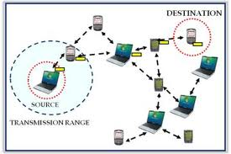

Structure of MANET

**How MANET works?**

The purpose of the MANET working group is to standardize IP routing protocol functionality suitable for wireless routing application within both static and dynamic topologies with increased dynamics due to node motion and other factors.  
  
Approaches are intended to be relatively lightweight in nature, suitable for multiple hardware and wireless environments, and address scenarios where MANETs are deployed at the edges of an IP infrastructure. Hybrid mesh infrastructures (e.g., a mixture of fixed and mobile routers) should also be supported by MANET specifications and management features.  
  
Using mature components from previous work on experimental reactive and proactive protocols, the WG will develop two Standards track routing protocol specifications:

* Reactive MANET Protocol(RMP)
* Proactive MANET Protocol(PMP)

If significant commonality between RMRP and PMRP protocol modules is observed, the WG may decide to go with a converged approach. Both IPv4 and IPv6 will be supported. Routing security requirements and issues will also be addressed.  
  
The MANET WG will also develop a scoped forwarding protocol that can efficiently flood data packets to all participating MANET nodes. The primary purpose of this mechanism is a simplified best effort multicast  
`forwarding function. The use of this protocol is intended to be applied ONLY within MANET routing areas and the WG effort will be limited to routing layer design issues.  
  
The MANET WG will pay attention to the OSPF-MANET protocol work within the OSPF WG and IRTF work that is addressing research topics related to MANET environments.

**Characteristics of MANET’s:**

* In MANET, each node acts as both host and router. That is it is autonomous in behavior.
* Multi-hop radio relaying- When a source node and destination node for a message is out of the radio range, the MANETs are capable of multi-hop routing.
* Distributed nature of operation for security, routing and host configuration. A centralized firewall is absent here.
* The nodes can join or leave the network anytime, making the network topology dynamic in nature.
* Mobile nodes are characterized with less memory, power and light weight features.
* The reliability, efficiency, stability and capacity of wireless links are often inferior when compared with wired links. This shows the fluctuating link bandwidth of wireless links.
* Mobile and spontaneous behavior which demands minimum human intervention to configure the network.
* All nodes have identical features with similar responsibilities and capabilities and hence it forms a completely symmetric environment.
* `High user density and large level of user mobility.
* Nodal connectivity is intermittent.
  1. **Infrastructure-based Networks:**
* Fixed backbone
* Nodes communicate with access point
* Suitable for areas where APs are provided

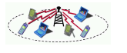

* 1. **Infrastructure-less Networks**
* Without any backbone and access point
* Every station is simultaneously router

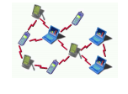

* 1. **Nodes:**
* limited resources
* dynamic topology
* Address assignment
  1. **Wireless channels:**
* relatively high error rate
* high variability in the quality
* low bandwidth
* broadcast nature
* security aspect

**Types of MANET:**

There are different types of MANETs including:

* In VANETs – Intelligent vehicular ad hoc networks make use of artificial intelligence to tackle unexpected situations like vehicle collision and accidents.
* Vehicular ad hoc networks (VANETs) – Enables effective communication with another vehicle or helps to communicate with roadside equipments.
* Internet Based Mobile Ad hoc Networks (iMANET) – helps to link fixed as well as mobile nodes.

**Types of routing protocols in the MANET:**

Two types of routing protocols:

* 1. Table-Driven Routing Protocols
     + Destination-Sequenced Distance-Vector Routing (DSDV)
     + Cluster head Gateway Switch Routing (CGSR)
     + The Wireless Routing Protocol (WRP)
  2. Source-Initiated On-Demand Routing Protocols
     + Ad-Hoc On-Demand Distance Vector Routing (AODV)
     + Dynamic Source Routing (DSR)
     + Temporally-Ordered Routing Algorithm (TORA)
     + Associativity-Based Routing (ABR)
     + Signal Stability Routing (SSR)

**Advantages of MANET’s:**

* + - Wireless communication
    - Mobility
    - Do not need infrastructure
    - but can use it, if available
    - small, light equipment

**1.2 Features**

* High Packet delivery ratio,.
* Increase Throughput.
* Low End-to-end-delay
* Less Energy consumption and More Network lifetime.

**1.3 Organization of Chapters**

In Chapter 1 we introduce about the project concept and give an overview idea about the project. In Chapter 2, we discuss about the project domain and the detailed description of existing systems by analysis the literature survey of the existing techniques. We also then presented about the techniques and methods of our proposed methods. In our proposed method we also listed out the advantages of using our proposed method. Then we presented the differences between the existing system and proposed system as a tabular representation stating the advantages of our proposed system. In Chapter 3, we made a system analysis of the methods we propose. In Chapter 4, we listed the Hardware requirements and Software Requirements of our project. In Chapter 5, we presented the modules and their description. Then we also depicted the Use-case diagram of our project, then we depicted Class diagram of our project. In Chapter 6, we concluded our proposal and then in Chapter 7 we list out our references made for our proposed method.

**CHAPTER 2- LITERATURE SURVEY**

**1) A cluster-based approach to consensus based distributed task allocation**

**AUTHORS:** D. Smith, J. Wetherall

This paper presents a novel extension to the Consensus-Based Bundle Algorithm (CBBA), which we have named Cluster-Formed Consensus-Based Bundle Algorithm (CFCBBA). CF-CBBA is designed to reduce the amount of communication required to complete a distributed task allocation process, by partitioning the problem and processing it in parallel clusters. CF-CBBA has been shown, in comparison with baseline CBBA, to require less communication when allocating tasks. Three key aspects of task allocation have been investigated, (a) the time taken to allocate tasks, (b) the amount of communication necessary to satisfy the requirements of distributed task allocation algorithms such as CBBA, and (c) the efficiency with which a collection of tasks (a mission) is completed by a group of robots (a collective).

**2) Aodv routing protocol implementation design**

**AUTHORS:** I. D. Chakeres and E. M. Belding-Royer

To date, the majority of ad hoc routing protocol researchhas been done using simulation only. One of the most motivatingreasons to use simulation is the difficulty of creatinga real implementation. In a simulator, the code is containedwithin a single logical component, which is clearly definedand accessible. On the other hand, creating an implementationrequires use of a system with many components, includingmany that have little or no documentation. The implementationdeveloper must understand not only the routingprotocol, but all the system components and their complexinteractions. Further, since ad hoc routing protocolsare significantly different from traditional routing protocols,a new set of features must be introduced to support therouting protocol. In this paper we describe the event triggersrequired for AODV operation, the design possibilitiesand the decisions for our Ad hoc On-demand Distance Vector(AODV) routing protocol implementation, AODV-UCSB.This paper is meant to aid researchers in developing theirown on-demand ad hoc routing protocols and assist usersin determining the implementation design that best fits theirneeds.

**3) Optimized link state routing protocol (olsr)**

**AUTHORS:** T. Clausen, P. Jacquet

In this paper we propose and discuss an optimized link state routing protocol, named OLSR, for mobile wireless networks. The protocol is based on the link state algorithm and it is proactive (or table-driven) in nature. It employs periodic exchange of messages to maintain topology information of the network at each node. OLSR is an optimization over a pure link state protocol as it compacts the size of information sent in the messages, and furthermore, reduces the number of retransmissions to flood these messages in an entire network. For this purpose, the protocol uses the multipoint relaying technique to efficiently and economically flood its control messages. It provides optimal routes in terms of number of hops, which are immediately available when needed. The proposed protocol is best suitable for large and dense ad hoc networks.

**4) Simulation-based performance evaluation of mobile ad hoc routing protocols in a swarm of unmanned aerial vehicles**

**AUTHORS:** M. Hyland, B. E. Mullins

This paper evaluates the performance of several ad hoc routing protocols in the context of a swarm of autonomous unmanned aerial vehicles (UAVs). It has been proposed that a wireless network where nodes have on average 5.1774 log n neighbors, where n is the total number of network nodes, has a high probability of having no partitions. By decreasing transmission range and implementing multi-hop routing between nodes, while ensuring network connectivity is maintained, spatial multiplexing of the wireless channel is exploited. The proposed process is evaluated using the OPNET network simulation tool for the Greedy Perimeter Stateless Routing (GPSR), Optimized Link State Routing (OLSR), and Ad hoc On- demand Distance Vector (AODV) routing protocols in the context of a swarm of UAVs.

**5) Performance analysis of mesh routing protocols for uav swarming applications**

**AUTHORS:** J. Pojda, A. Wolff

Unmanned Aerial Vehicles (UAVs) are an emerging technology offering new opportunities for innovative applications and efficient overall process management in the areas of public security, cellular networks and surveying. A key factor for the optimizations yielded by this technology is an advanced mesh network design for fast and reliable information sharing between UAVs. In this paper, we analyze the performance of four available mesh routing protocol implementations (open80211s, BATMAN, BATMAN Advanced and OLSR) in the context of swarming applications for UAVs. The protocols are analyzed by means of goodput in one static and one mobile scenario using the same embedded hardware platform installed at UAVs in current research projects. Our results show that layer-2 protocols suit better for mobile applications in comparison to layer-3. On the other hand, they often cause routing flippings, which are unwanted route changes, in static scenarios imposing a small performance decrease. Hence, given the aforementioned routing protocols, we recommend to currently use open80211s or batman-advanced to establish a reliable multi-hop mesh network for swarming applications.

**CHAPTER 3- SYSTEM ANALYSIS**

**EXISTING SYSTEM:**

* Sun et al. proposed an Energy-entropy Multipath Routing optimization algorithm in MANET based on GA (EMRGA).
* The key idea of the protocol was to find the minimal node residual energy of each route in the process of selecting a path by descending node residual energy.
* It can balance individual nodes battery power utilization and hence prolong the entire networks lifetime and energy variance.

**DISADVANTAGES OF EXISTING SYSTEM:**

* Less Packet delivery ratio
* Low Throughput
* High End-to-end-delay
* More Energy consumption and Less Network lifetime.

**PROPOSED SYSTEM:**

* We proposed a new multipath routing protocol called the FF-AOMDV routing protocol, which is a combination of Fitness Function and the AOMDV’s protocol.
* In a normal scenario, when a RREQ is broadcasted by a source node, more than one route to the destination will be found and the data packets will be forwarded through these routes without knowing the routes’ quality.
* By implementing the proposed algorithm on the same scenario, the route selection will be totally different. When a RREQ is broadcast and received, the source node will have three (3) types of information in order to find the shortest and optimized route path with minimized energy consumption.

**ADVANTAGES OF PROPOSED SYSTEM:**

* High Packet delivery ratio,.
* Increase Throughput.
* Low End-to-end-delay
* Less Energy consumption and More Network lifetime.

**CHAPTER – 4 SYSTEM STUDY**

**FEASIBILITY STUDY**

The feasibility of the project is analyzed in this phase and business proposal is put forth with a very general plan for the project and some cost estimates. During system analysis the feasibility study of the proposed system is to be carried out. This is to ensure that the proposed system is not a burden to the company. For feasibility analysis, some understanding of the major requirements for the system is essential.

Three key considerations involved in the feasibility analysis are

* ECONOMICAL FEASIBILITY
* TECHNICAL FEASIBILITY
* SOCIAL FEASIBILITY

**ECONOMICAL FEASIBILITY**

This study is carried out to check the economic impact that the system will have on the organization. The amount of fund that the company can pour into the research and development of the system is limited. The expenditures must be justified. Thus the developed system as well within the budget and this was achieved because most of the technologies used are freely available. Only the customized products had to be purchased.

### TECHNICAL FEASIBILITY

This study is carried out to check the technical feasibility, that is, the technical requirements of the system. Any system developed must not have a high demand on the available technical resources. This will lead to high demands on the available technical resources. This will lead to high demands being placed on the client. The developed system must have a modest requirement, as only minimal or null changes are required for implementing this system.

**SOCIAL FEASIBILITY**

The aspect of study is to check the level of acceptance of the system by the user. This includes the process of training the user to use the system efficiently. The user must not feel threatened by the system, instead must accept it as a necessity. The level of acceptance by the users solely depends on the methods that are employed to educate the user about the system and to make him familiar with it. His level of confidence must be raised so that he is also able to make some constructive criticism, which is welcomed, as he is the final user of the system.

**CHAPTER 5- SYSTEM REQUIREMENTS**

**SYSTEM REQUIREMENTS:**

# HARDWARE REQUIREMENTS:-

# Processor -Pentium –III

* Speed - 1.1 Ghz
* RAM - 256 MB(min)
* Hard Disk - 20 GB
* Floppy Drive - 1.44 MB
* Key Board - Standard Windows Keyboard
* Mouse - Two or Three Button Mouse
* Monitor - SVGA

# SOFTWARE REQUIREMENTS:-

* Operating System : LINUX
* Tool : Network Simulator-2
* Front End :OTCL (Object Oriented Tool Command Language)

**CHAPTER 6- MODULE DESCRIPTION**

**MODULES:**

* Simulation Model
* Fitness Function
* FF-AOMDV

**MODULE DESCRIPTIONS:**

**Simulation Model:**

In this simulation model, we utilized the Constant Bit Rate (CBR) as a traffic source with 36 mobile nodes that are distributed randomly in a 1500 m* 1500 m network area; the network topology may therefore, undergo random change since the nodes’ distribution and its movement are random. The transmission range of the nodes was set to 250 m, while, for each node, the initial energy level was set to 100 joules. Three different scenarios were chosen to see how they are affecting the performance of the proposed FF-AOMDV protocol. In the first scenario, we varied the packet size as (64, 128, 256, 512, 1024) bytes and kept both the node speed and simulation time fixed as (2.5 meter/second and for 50 seconds) respectively. All other network parameters are the same for all runs and for all simulated protocols. In the second scenario, we varied the node speed as (0, 2.5, 5, 7.5, 10) seconds and kept the packet size and simulation time fixed as (256 bytes and 50 seconds) respectively. Finally, in the third scenario, we varied the simulation time as (10, 20, 30, 40, 50) seconds and kept the both the node speed and packet size fixed as (2.5 meters/second and 256 bytes) respectively.

**Fitness Function:**

The fitness function is an optimization technique that comes as a part of many optimization algorithms such as genetic algorithm, bee colony algorithm, firefly algorithm and particle swarm optimization algorithm. The fitness function finds the most important factor in the optimization process, which could be many factors depending on the aim of the research. In MANET, the fitness factor is usually energy, distance, delay, and bandwidth. This matches the reasons for designing any routing protocol, as they aim to enhance the network resources. In this research, the fitness function used is part of the Particle Swarm Optimization (PSO) algorithm. It was used with wireless sensor networks to optimize the alternative route in case the primary route fails. The factors that affect the choice of the optimum route are:

* The remaining energy functions for each node
* The distance functions of the links connecting the neighboring nodes
* Energy consumption of the nodes
* Communication delay of the nodes

**FF-AOMDV:**

In a normal scenario, when a RREQ is broadcasted by a source node, more than one route to the destination will be found and the data packets will be forwarded through these routes without knowing the routes’ quality. By implementing the proposed algorithm on the same scenario, the route selection will be totally different. When a RREQ is broadcast and received, the source node will have three (3) types of information in order to find the shortest and optimized route path with minimized energy consumption. This information includes:

* Information about network’s each node’s energy level
* The distance of every route
* The energy consumed in the process of route discovery.

The route, which consumes less energy, could possibly be (a) the route that has the shortest distance; (b) the route with the highest level of energy, or (c) both. The source node will then sends the data packets via the route with highest energy level, after which it will calculate its energy consumption. Alike to other multipath routing protocols, this protocol will also initiates new route discovery process when all routes to the destination are failed. In the event when the selected route fails, the source node will then selects an alternative route from its routing table, which represents the shortest route with minimum energy consumption. The optimal route with less distance to destination will consume less energy.

**CHAPTER 7 DESIGN**

**INPUT DESIGN**

The input design is the link between the information system and the user. It comprises the developing specification and procedures for data preparation and those steps are necessary to put transaction data in to a usable form for processing can be achieved by inspecting the computer to read data from a written or printed document or it can occur by having people keying the data directly into the system. The design of input focuses on controlling the amount of input required, controlling the errors, avoiding delay, avoiding extra steps and keeping the process simple. The input is designed in such a way so that it provides security and ease of use with retaining the privacy. Input Design considered the following things:

* What data should be given as input?
* How the data should be arranged or coded?
* The dialog to guide the operating personnel in providing input.
* Methods for preparing input validations and steps to follow when error occur.

**OBJECTIVES**

1. Input Design is the process of converting a user-oriented description of the input into a computer-based system. This design is important to avoid errors in the data input process and show the correct direction to the management for getting correct information from the computerized system.

2. It is achieved by creating user-friendly screens for the data entry to handle large volume of data. The goal of designing input is to make data entry easier and to be free from errors. The data entry screen is designed in such a way that all the data manipulates can be performed. It also provides record viewing facilities.

3. When the data is entered it will check for its validity. Data can be entered with the help of screens. Appropriate messages are provided as when needed so that the user will not be in maize of instant. Thus the objective of input design is to create an input layout that is easy to follow.

**OUTPUT DESIGN**

A quality output is one, which meets the requirements of the end user and presents the information clearly. In any system results of processing are communicated to the users and to other system through outputs. In output design it is determined how the information is to be displaced for immediate need and also the hard copy output. It is the most important and direct source information to the user. Efficient and intelligent output design improves the system’s relationship to help user decision-making.

1. Designing computer output should proceed in an organized, well thought out manner; the right output must be developed while ensuring that each output element is designed so that people will find the system can use easily and effectively. When analysis design computer output, they should Identify the specific output that is needed to meet the requirements.

2. Select methods for presenting information.

3. Create document, report, or other formats that contain information produced by the system.

The output form of an information system should accomplish one or more of the following objectives.

* Convey information about past activities, current status or projections of the
* Future.
* Signal important events, opportunities, problems, or warnings.
* Trigger an action.
* Confirm an action.

**CHAPTER 8 - SOFTWARE DESCRIPTION**

**THE NETWORK SIMULATOR 2.33 (NS2)**

Network Simulator (NS2) is a discrete event driven simulator developed at UC Berkeley. It is part of the VINT project. The goal of NS2 is to support networking research and education. It is suitable for designing new protocols, comparing different protocols and traffic evaluations. NS2 is developed as a collaborative environment. It is distributed freely and open source. A large amount of institutes and people in development and research use, maintain and develop NS2. This increases the confidence in it. Versions are available for FreeBSD, Linux, Solaris, Windows and Mac OS X.

**STRUCTURE OF NS2**

NS2 is built using object oriented methods in C++ and OTcl (object oriented variant of Tcl.



**Fig 5.1 Simplified User’s View of Ns**

can see in Fig 5.1, NS2 interprets the simulation scripts written in OTcl. A user has to set the different components (e.g. event scheduler objects, network components libraries and setup module libraries) up in the simulation environment. The user writes his simulation as a OTcl script, plumbs the network components together to the complete simulation. If he needs new network components, he is free to implement them and to set them up in his simulation as well. The event scheduler as the other major component besides network components triggers the events of the simulation (e.g. sends packets, starts and stops tracing). Some parts of NS2 are written in C++ for efficiency reasons. The data path (written in C++) is separated from the control path (written in OTcl). Data path object are compiled and then made available to the OTcl interpreter through an OTcl linkage (tclcl) which maps methods and member variables of the C++ object to methods and variables of the linked OTcl object. The C++ objects are controlled by OTcl objects. It is possible to add methods and member variables to a C++ linked OTcl object.

**FUNCTIONALITIES OF NS2.33**

Functionalities for wired, wireless networks, tracing, and visualization are available in NS2.

• Support for the wired world include

**–** Routing DV, LS, and PIM-SM.

**–** Transport protocols: TCP and UDP for unicast and SRM for multicast.

**–** Traffic sources: web, ftp, telnet, cbr (constant bit rate), stochastic, real audio.

**–** Different types of Queues: drop-tail, RED, FQ, SFQ, DRR.

**–** Quality of Service: Integrated Services and Differentiated Services.

**–** Emulation.

• Support for the wireless world include

**–** Ad hoc routing with different protocols, e.g. AODV, DSR, DSDV, TORA

**–** Wired-cum-wireless networks

**–** Mobile IP

**–** Directed diffusion

**–** Satellite

**–** Senso-MAC

**–** Multiple propagation models (Free space, two-ray ground, shadowing)

**–** Energy models

• Tracing

• Visualization

**–** Network Animator (NAM)

**–** Trace Graph

• Utilities

**–** Mobile Movement Generator



**Fig 5.2 OTcl and C++: the duality**

**MOBILE NETWORKING IN NS2.33**

This section describes the wireless model that was originally ported as CMU’s Monarch group’s mobility extension to NS2. The first section covers the original mobility model ported from CMU/Monarch group. In this section, we cover the internals of a mobile node, routing mechanisms and network components that are used to construct the network stack for a mobile node. The components that are covered briefly are Channel, Network interface, Radio propagation model, MAC protocols, Interface Queue, Link layer and Address resolution protocol model (ARP). CMU trace support and Generation of node movement and traffic scenario files are also covered in this section. The original CMU model allows simulation of pure wireless LANs or multihop ad-hoc networks. Further extensions were made to this model to allow combined simulation of wired and wireless networks. MobileIP was also extended to the wireless model.

**THE BASIC WIRELESS MODEL IN NS**

The wireless model essentially consists of the MobileNode at the core, with additional supporting features that allows simulations of multi-hop ad-hoc networks, wireless LANs etc. The MobileNode object is a split object. The C++ class MobileNode is derived from parent class Node. A MobileNode thus is the basic Node object with added functionalities of a wireless and mobile node like ability to move within a given topology, ability to receive and transmit signals to and from a wireless channel etc. A major difference between them, though, is that a MobileNode is not connected by means of Links to other nodes or mobilenodes. In this section we shall describe the internals of MobileNode, its routing mechanisms, the routing protocols dsdv, aodv, tora and dsr, creation of network stack allowing channel access in MobileNode, brief description of each stack component, trace support and movement/traffic scenario generation for wireless simulations.

**MOBILE NODE: CREATING WIRELESS TOPOLOGY**

MobileNode is the basic *ns*Node object with added functionalities like movement, ability to transmit and receive on a channel that allows it to be used to create mobile, wireless simulation environments. The class MobileNode is derived from the base class Node. MobileNode is a split object. The mobility features including node movement, periodic position updates, maintaining topology boundary etc are implemented in C++ while plumbing of network components within MobileNode itself (like classifiers, dmux , LL, Mac, Channel etc) have been implemented in Otcl.

**Table 5.1: Available Options For Node Configuration**

|  |  |  |
| --- | --- | --- |
| **Option** | **Available Values** | **Default** |
| **General** | | |
| Address type | Flat, Hierarchical | Flat |
| MPLS | ON,OFF | OFF |
| **Both Satellite and Wireless Oriented** | | |
| Wired Routing | ON,OFF | OFF |
| II Type | LL,LL/sat | OFF |
| Mac Type | Mac/802_11,Mac/Csma/Ca, Mac/Sat/Unslotted/Aloha,Mac/Tdma | OFF |
| ifq Type | Queue/DropTail, Queue/Droptail/PriQueue | OFF |
| Phy Type | Phy/wirelessPhy,Physat | OFF |

|  |  |  |
| --- | --- | --- |
| **Option** | **Available Values** | **Default** |
| **Satellite Oriented** | | |
| satNodeType | Polar,Geo,Terminal,Geo-repeater | OFF |
| downlinkBW | <bandwidth value, e.g “2MB”> | OFF |
| **Wireless Oriented** | | |
| Adhoc Routing | DIFFUSION/RATE,DIFFUSION/PROB,  DSDV,FLOODING,OMNICAST,AODV,TORA | OFF |
| propType | Propagation/2RayGround,Propagation Shadowing | OFF |
| propInstance | Propagation/2RayGround,Propagation Shadowing | OFF |
| antType | Antenna/Omni Antenna | OFF |
| Channel | Channel/Wireless Channel,Channel/sat | OFF |
| topoInstance | <toplogy file> | OFF |
| MobileIP | ON,OFF | OFF |
| Energy model | Energy model | OFF |
| Initial Energy | <value in joules> | OFF |
| rxPower | <value in W> | OFF |
| txPower | <value in W> | OFF |
| Idle Power | <value in W> | OFF |
| AgentTrace | ON,OFF | OFF |
| routerTrace | ON,OFF | OFF |
| macTrace | ON,OFF | OFF |
| movementTrace | ON,OFF | OFF |
| Errproc | UniformErrorProc | OFF |
| FECProc | ? | ? |
| toraDebug | ON,OFF | OFF |

**CHAPTER 9**

**IMPLEMENTATION ENVIRONMENT**

Network simulator 2 is used as the simulation tool in this project. NS was chosen as the simulator partly because of the range of features it provides and partly because it has an open source code that can be modified and extended. There are different versions of NS and the latest version is ns-2.1b9a while ns-2.1b10 is under development

**NETWORK SIMULATOR (NS)**

Network simulator (NS) is an object–oriented, discrete event simulator for networking research. NS provides substantial support for simulation of TCP, routing and multicast protocols over wired and wireless networks. The simulator is a result of an ongoing effort of research and developed. Even though there is a considerable confidence in NS, it is not a polished product yet and bugs are being discovered and corrected continuously.

NS is written in C++, with an OTcl1 interpreter as a command and configuration interface. The C++ part, which is fast to run but slower to change, is used for detailed protocol implementation. The OTcl part, on the other hand, which runs much slower but can be changed very fast

quickly, is used for simulation configuration. One of the advantages of this split-language program approach is that it allows for fast generation of large scenarios. To simply use the simulator, it is sufficient to know

OTcl. On the other hand, one disadvantage is that modifying and extending the simulator requires programming and debugging in both languages.

NS can simulate the following:

**1. Topology:** Wired, wireless

**2. Sheduling Algorithms:** RED, Drop Tail,

**3. Transport Protocols:** TCP, UDP

**4. Routing:** Static and dynamic routing

**5. Application:** FTP, HTTP, Telnet, Traffic generators

**USER’S VIEW OF NS-2**

**Simulation -**

**OTcl Script**

**OTcl Interpreter**

**Simulation Results**

**C++ Libraries**

**Figure 5.1** Block diagram of Architecture of NS-2

**NETWORK Components**

This section talks about the NS components, mostly compound network components. Figure 1.1 shows a partial OTcl class hierarchy of NS, which will help understanding the basic network components.

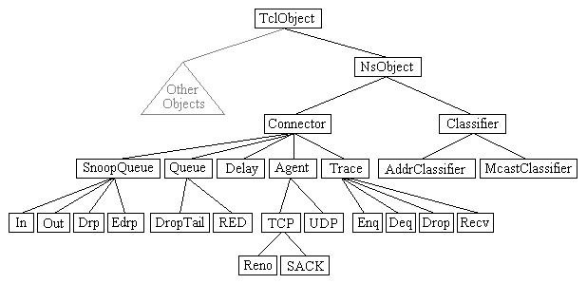

**Figure 5.2** OTcl Class Hierarchy

The root of the hierarchy is the TclObject class that is the super class of all OTcl library objects (scheduler, network components, timers and the other objects including NAM related ones). As an ancestor class of TclObject, NsObject class is the super class of all basic network component objects that handle packets, which may compose compound network objects such as nodes and links. The basic network components are further divided into two subclasses, Connector and Classifier, based on the number of the possible output DATA paths. The basic network and

objects that have only one output DATA path are under the Connector class, and switching objects that have possible multiple output DATA paths are under the Classifier class.

**CLASS TCL**

The class Tcl encapsulates the actual instance of the OTcl interpreter and provides the methods to access and communicate with that interpreter, code. The class provides methods for the following operations:

1. Obtain a reference to the Tel instance

2. Invoke OTcl procedures through the interpreter

3. Retrieve, or pass back results to the interpreter

4. Report error situations and exit in an uniform manner

5. Store and lookup "Tcl Objects"

6. Acquire direct access to the interpreter.

**Obtain a Reference to the class Tcl instance**

A single instance of the class is declared in -tclcl/Tcl.cc as a static member variable. The statement required to access this instance is Tel& tel = Tcl::instance();

**Invoking OTcl Procedures**

There are four different methods to invoke an OTcl command through the instance, tcl. They differ essentially in their calling arguments. Each function passes a string to the interpreter that then evaluates the string in a global context. These methods will return to the caller if the interpreter returns TCL_OK. On the other hand, if the interpreter returns TCL_ERROR, the methods will call tkerror{}. The user can overload this procedure to selectively disregard certain types of errors.

1. **Passing Results to/from the Interpreter :** When the interpreter invokes a C++ method, it expects the result back in the private member variable, tcl-> result.
2. **Error Reporting and Exit:** This method provides a uniform way to report errors in the compiled code.

**COMMAND METHODS: DEFINITION AND INVOCATION**

For every Tcl Object that is created, ns establishes the instance procedure,cmd{}, as a hook to executing methods through the compiled shadow object. The procedure cmd{} invokes the method command() of the shadow object automatically, passing the arguments to cmd{} as an argument vector to the command() method. The user can invoke the cmd {} method in one of two ways, by explicitly invoking the procedure, specifying the desired operation as the first argument, or implicitly, as if

there were an instance procedure of the same name as the desired operation. Most simulation scripts will use the latter form.

Consider the distance computation in SRM is done by the compiled object. It is often used by the interpreted object. It is usually invoked as $srmObject distance? (agentAddress)If there is no instance procedure called distance? the interpreter will invoke the instance procedure unknown{}, defined in the base class TclObject. The unknown procedure then invokes

$srmObject cmd distance? (agentAddress)

to execute the operation through the compiled object's command() procedure. The user could explicitly invoke the operation directly. One reason for this might be to overload the operation by using an instance procedure of the same name.

For example,

Agent/SRM/Adaptive instproc distance? addr {

$self instvar distanceCache_($addr)

if![info exists distanceCache_($addr)] {

set distanceCache_($addr) [$self cmd distance? $addr]

}

set distanceCache_($addr)

}

The following shows how the command() method using SRMAgent::command()

int ASRMAgent::command(int argc, const char*const*argv) {

Tcl& tcl = Tcl::instance();

if (argc == 3) {

if (strcmp(argv[1], "distance?") == 0) {

int sender = atoi(argv[2]);

SRMinfo* sp = get_state(sender);

tcl.tesultf("%f", sp->distance_);

return TCL_OK; '

}

}

return (SRMAgent::command(argc, argv));

The following observations are made from this piece of code:

The function is called with two arguments. The first argument (argc) indicates the number of arguments specified in the command line to the interpreter. The command line arguments vector (argv) consists of argv[0] contains the name of the method, "cmd" and argv[1] specifies the desired operation. If the user specified any arguments, then they are placed in argv[2...(argc - 1)]. The arguments are passed as strings. They must be converted to the appropriate data type.If the operation is successfully matched, the match should return the result of the operation,command () itself must return either TCL_OK or TCL_ERROR to indicate success or failure as its return code. If matched in this method, it must invoke its parent's command method, and return the corresponding result. This permits the user to conceive of operations as having the same inheritance properties as instance procedures or compiled methods.In the event that this command method is defined for a class with multipleinheritance, one of two implementations can be chosen

1. Either they can invoke one of the parent's command method, and return the result of that invocation.

2.They can each of the parent's command methods in some sequence, and return the result of the first invocation that is successful. If none of them are successful, then they should return an error.

**MOBILE NETWORKING IN NS**

The wireless model essentially consists of the Mobile Node at the core with additional supporting features that allows simulations of multi-hop ad-hoc networks, wireless LANs etc. The Mobile Node object is a split object. The C++ class Mobile Node is derived from parent class Node. A Mobile Node thus is the basic Node object with added functionalities of a wireless and mobile node like ability to move within a given topology, ability to receive and transmit signals to and from a wireless channel etc. A major difference between them is that a mobile Node is not connected by means of Links to other nodes or mobile nodes.

Mobile Node is the basic nsNode object with added functionalities like movement, ability to transmit and receive on a channel that allows it to be used to create mobile, wireless simulation environments. The class Mobile Node is derived from the base class Node. The four ad-hoc routing protocols that are currently supported are, Dynamic Source Routing (DSR), Temporally ordered Routing Algorithm (TORA) and Adhoc On-demand Distance Vector (AODV).

The general structure for defining a mobile node in ns2 is described as follows:

$ns node-config -adhocRouting $opt (adhocRouting)

-IIType $opt (II)

-macType $opt (mac)

-ifqType $opt (ifq) -ifqLen $opt (ifqlen)

-antType $opt (ant)

-proplnstance [new $opt (prop) -phyType $opt (netif)

-channel [new $opt (chan)]

-topolnstance $topo

-wiredRouting OFF

-agentTrace ON

-routerTrace OFF

-macTrace OFF

The above API configures for a mobile node with all the given values of ad hoc-routing protocol, network stack, channel, topography, propagation model, with wired routing turned on or off (required for wired-cum-wireless scenarios) and tracing turned on or off at different levels (router, mac, agent).

**CHAPTER 10- SYSTEM DESIGN:**

**SYSTEM ARCHITECTURE**

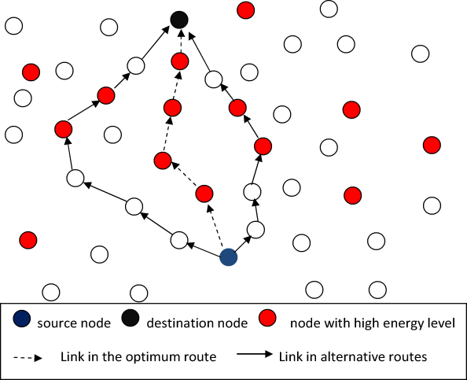

**DATA FLOW DIAGRAM:**

1. The DFD is also called as bubble chart. It is a simple graphical formalism that can be used to represent a system in terms of input data to the system, various processing carried out on this data, and the output data is generated by this system.
2. The data flow diagram (DFD) is one of the most important modeling tools. It is used to model the system components. These components are the system process, the data used by the process, an external entity that interacts with the system and the information flows in the system.
3. DFD shows how the information moves through the system and how it is modified by a series of transformations. It is a graphical technique that depicts information flow and the transformations that are applied as data moves from input to output.
4. DFD is also known as bubble chart. A DFD may be used to represent a system at any level of abstraction. DFD may be partitioned into levels that represent increasing information flow and functional detail.

Broadcasting RREQ

Calculate each node’s energy level

Compute Distance of every route

Energy consumed in the process of route discovery

Select the Optimal Path

Receive File

Source

IP Address

Destination

Wait for Response

IP Address

Router

Send File

IP Address

Choose File

**UML DIAGRAMS**

UML stands for Unified Modeling Language. UML is a standardized general-purpose modeling language in the field of object-oriented software engineering. The standard is managed, and was created by, the Object Management Group.

The goal is for UML to become a common language for creating models of object oriented computer software. In its current form UML is comprised of two major components: a Meta-model and a notation. In the future, some form of method or process may also be added to; or associated with, UML.

The Unified Modeling Language is a standard language for specifying, Visualization, Constructing and documenting the artifacts of software system, as well as for business modeling and other non-software systems.

The UML represents a collection of best engineering practices that have proven successful in the modeling of large and complex systems.

The UML is a very important part of developing objects oriented software and the software development process. The UML uses mostly graphical notations to express the design of software projects.

**GOALS:**

The Primary goals in the design of the UML are as follows:

1. Provide users a ready-to-use, expressive visual modeling Language so that they can develop and exchange meaningful models.
2. Provide extendibility and specialization mechanisms to extend the core concepts.
3. Be independent of particular programming languages and development process.
4. Provide a formal basis for understanding the modeling language.
5. Encourage the growth of OO tools market.
6. Support higher level development concepts such as collaborations, frameworks, patterns and components.
7. Integrate best practices.

**USE CASE DIAGRAM:**

A use case diagram in the Unified Modeling Language (UML) is a type of behavioral diagram defined by and created from a Use-case analysis. Its purpose is to present a graphical overview of the functionality provided by a system in terms of actors, their goals (represented as use cases), and any dependencies between those use cases. The main purpose of a use case diagram is to show what system functions are performed for which actor. Roles of the actors in the system can be depicted.

Source

Router

Destination

**CLASS DIAGRAM:**

In software engineering, a class diagram in the Unified Modeling Language (UML) is a type of static structure diagram that describes the structure of a system by showing the system's classes, their attributes, operations (or methods), and the relationships among the classes. It explains which class contains information.

Destination

IP Address

Wait for Response () Receive File ()

Source

IP Address

Choose File () Send File ()

Router

IP Address

Broadcasting RREQ () Calculate each node’s energy level () Compute Distance of every route () Energy consumed () Select the Optimal Path ()

**SEQUENCE DIAGRAM:**

A sequence diagram in Unified Modeling Language (UML) is a kind of interaction diagram that shows how processes operate with one another and in what order. It is a construct of a Message Sequence Chart. Sequence diagrams are sometimes called event diagrams, event scenarios, and timing diagrams.

Destination

Source

Router

IP Address

Choose & Send File

Compute Distance of every route

Broadcasting RREQ

Calculate each node’s energy level

Energy consumed in the process of route discovery

Energy consumed in the process of route discovery

Select the Optimal Path

**ACTIVITY DIAGRAM:**

Activity diagrams are graphical representations of workflows of stepwise activities and actions with support for choice, iteration and concurrency. In the Unified Modeling Language, activity diagrams can be used to describe the business and operational step-by-step workflows of components in a system. An activity diagram shows the overall flow of control.

Choose File

IP Address

IP Address

Source

Login

Router

Destination

Wait for Response

Broadcasting RREQ

IP Address

Receive File

Send File

Calculate each node’s energy level

Compute Distance of every route

Energy consumed in the process of route discovery

Select the Optimal Path

### CHAPTER 11: SYSTEM TESTING

The purpose of testing is to discover errors. Testing is the process of trying to discover every conceivable fault or weakness in a work product. It provides a way to check the functionality of components, sub assemblies, assemblies and/or a finished product It is the process of exercising software with the intent of ensuring that the

Software system meets its requirements and user expectations and does not fail in an unacceptable manner. There are various types of test. Each test type addresses a specific testing requirement.

**TYPES OF TESTS**

**Unit testing**

Unit testing involves the design of test cases that validate that the internal program logic is functioning properly, and that program inputs produce valid outputs. All decision branches and internal code flow should be validated. It is the testing of individual software units of the application .it is done after the completion of an individual unit before integration. This is a structural testing, that relies on knowledge of its construction and is invasive. Unit tests perform basic tests at component level and test a specific business process, application, and/or system configuration. Unit tests ensure that each unique path of a business process performs accurately to the documented specifications and contains clearly defined inputs and expected results.

**Integration testing**

Integration tests are designed to test integrated software components to determine if they actually run as one program. Testing is event driven and is more concerned with the basic outcome of screens or fields. Integration tests demonstrate that although the components were individually satisfaction, as shown by successfully unit testing, the combination of components is correct and consistent. Integration testing is specifically aimed at exposing the problems that arise from the combination of components.

**Functional test**

Functional tests provide systematic demonstrations that functions tested are available as specified by the business and technical requirements, system documentation, and user manuals.

Functional testing is centered on the following items:

Valid Input : identified classes of valid input must be accepted.

Invalid Input : identified classes of invalid input must be rejected.

Functions : identified functions must be exercised.

Output : identified classes of application outputs must be exercised.

Systems/Procedures: interfacing systems or procedures must be invoked.

Organization and preparation of functional tests is focused on requirements, key functions, or special test cases. In addition, systematic coverage pertaining to identify Business process flows; data fields, predefined processes, and successive processes must be considered for testing. Before functional testing is complete, additional tests are identified and the effective value of current tests is determined.

**System Test**

System testing ensures that the entire integrated software system meets requirements. It tests a configuration to ensure known and predictable results. An example of system testing is the configuration oriented system integration test. System testing is based on process descriptions and flows, emphasizing pre-driven process links and integration points.

**White Box Testing**

White Box Testing is a testing in which in which the software tester has knowledge of the inner workings, structure and language of the software, or at least its purpose. It is purpose. It is used to test areas that cannot be reached from a black box level.

**Black Box Testing**

Black Box Testing is testing the software without any knowledge of the inner workings, structure or language of the module being tested. Black box tests, as most other kinds of tests, must be written from a definitive source document, such as specification or requirements document, such as specification or requirements document. It is a testing in which the software under test is treated, as a black box .you cannot “see” into it. The test provides inputs and responds to outputs without considering how the software works.

**Unit Testing:**

Unit testing is usually conducted as part of a combined code and unit test phase of the software lifecycle, although it is not uncommon for coding and unit testing to be conducted as two distinct phases.

**Test strategy and approach**

Field testing will be performed manually and functional tests will be written in detail.

**Test objectives**

* All field entries must work properly.
* Pages must be activated from the identified link.
* The entry screen, messages and responses must not be delayed.

**Features to be tested**

* Verify that the entries are of the correct format
* No duplicate entries should be allowed
* All links should take the user to the correct page.

# Integration Testing

Software integration testing is the incremental integration testing of two or more integrated software components on a single platform to produce failures caused by interface defects.

The task of the integration test is to check that components or software applications, e.g. components in a software system or – one step up – software applications at the company level – interact without error.

**Test Results:** All the test cases mentioned above passed successfully. No defects encountered.

**Acceptance Testing**

User Acceptance Testing is a critical phase of any project and requires significant participation by the end user. It also ensures that the system meets the functional requirements.

**Test Results:** All the test cases mentioned above passed successfully. No defects encountered.

**CHAPTER 12- CONCLUSION**

In this research, we proposed a new energy efficient multipath routing algorithm called FF-AOMDV simulated using NS-2 under three different scenarios, varying node speed, packet size and simulation time. These scenarios were tested by five (5) performance metrics (Packet delivery ratio, Throughput, End-to-end-delay, Energy consumption and Network lifetime). Simulation results showed that the proposed FF-AOMDV algorithm has performed much better than both AOMR-LM and AOMDV in throughput, packet delivery ratio and end-to-end delay. It also performed well against AOMDV for conserving more energy and better network lifetime.

As a future work, there are several scenarios that could be implemented with this study to enhance the energy consumption and network lifetime. For instance, it is possible to consider another network resource which is the bandwidth as another fitness value. In this case the calculations for selecting routes towards the destination will be according to energy, distance and bandwidth. Basically this will consider many network resources which will prolong the network lifetime and enhances the QoS. Another possibility is to test the fitness function with another multipath routing protocol that has a different mechanism than AOMDV and compare the results with the proposed FF-AOMDV.

**CHAPTER 13- REFERENCES**

[1] Macker, J. (1999). Mobile ad hoc networking (MANET): Routing protocol performance issues and evaluation considerations.

[2] Giordano, S. (2002). Mobile ad hoc networks. *Handbook of wireless networks and mobile computing*, 325-346.

[3] Perkins, C. E. (2001). Ad hoc networking: an introduction, Ad hoc networking.

[4] Zheng, S., Weiqiang, W. U., & Zhang, Q. (2011). Energy and link-state based routing protocol for MANET. *IEICE TRANSACTIONS on Information and Systems*, *94*(5), 1026-1034.

[5] Marina, M. K., & Das, S. R. (2006). Ad hoc on‐demand multipath distance vector routing. *Wireless communications and mobile computing*, *6*(7), 9

[6] Tekaya, M., Tabbane, N., & Tabbane, S. (2010, November). Multipath routing mechanism with load balancing in ad hoc network. In *Computer Engineering and Systems (ICCES), 2010 International Conference on* (pp. 67-72). IEEE.

[7] Gatani, L., Re, G. L., & Gaglio, S. (2005, June). Notice of Violation of IEEE Publication Principles An adaptive routing protocol for ad hoc peer-to-peer networks. In Sixth IEEE international symposium on a world of wireless mobile and multimedia networks (pp. 44-50). IEEE.

[8] Yogesh Chaba, Patel, R. B., and Rajesh Gargi (2012). Issues and challenges involved in multipath routing with DYMO protocol. International Journal of Information Technology and Knowledge Management, January-June 2012, 5(1), pp. 21-25.

[9] Mueller, S., Tsang, R. P., & Ghosal, D. (2004). Multipath routing in mobile ad hoc networks: Issues and challenges. In *Performance tools and applications to networked systems* (pp. 209-234). Springer Berlin Heidelberg.

[10] Balaji, V., & Duraisamy, V. (2011). Varying Overhead Ad Hoc on Demand Vector Routing in Highly Mobile Ad Hoc Network. Journal of Computer Science, 7(5), pp. 678-682.

[11] Poonam M. and Preeti D. (2014). Packet Forwarding using AOMDV Algorithm in WSN. International Journal of Application or Innovation in Engineering & Management (IJAIEM), 2319 – 4847, 3(5), May 2014, pp. 456-459.

[12] Gimer Cervera, Michel Barbeau, Joaquin Garcia-Alfaro, and Evangelos Kranakis. (2013). A multipath routing strategy to prevent flooding disruption attacks in link state routing protocols for MANETs. Journal of Network and Computer Applications, 36(2), March 2013, 744-755.

[13] Marina, M. K., & Das, S. R. (2001, November). On-demand multipath distance vector routing in ad hoc networks. In *Network Protocols, 2001. Ninth International Conference on* (pp. 14-23). IEEE.

[14] Hu, Y. F., Ding, Y. S., Ren, L. H., Hao, K. R., & Han, H. (2015). An endocrine cooperative particle swarm optimization algorithm for routing recovery problem of wireless sensor networks with multiple mobile sinks. *Information Sciences*, *300*, 100-113.

[15] Montazeri, A., Poshtan, J., & Yousefi-Koma, A. (2008). The use of? particle swarm? to optimize the control system in a PZT laminated plate. *Smart Materials and Structures*, *17*(4), 045027.

[16] Chen, H. H., Li, G. Q., & Liao, H. L. (2009, August). A self-adaptive improved particle swarm optimization algorithm and its application in available transfer capability calculation. In *2009 Fifth International Conference on Natural Computation* (Vol. 3, pp. 200-205). IEEE.

[17] Trelea, I. C. 2003. The particle swarm optimization algorithm: convergence analysis and parameter selection. Information processing letters 85(6): 317-325.

[18] Smail, O., Cousin, B., Mekki, R., & Mekkakia, Z. (2014). A multipath energy-conserving routing protocol for wireless ad hoc networks lifetime improvement. *EURASIP Journal on Wireless Communications and Networking*, *2014* (1), 1-12.

[19] Manickavelu, D., & Vaidyanathan, R. U. (2014). Particle swarm optimization (PSO)-based node and link lifetime prediction algorithm for route recovery in MANET. *EURASIP Journal on Wireless Communications and Networking*, *2014* (1), 1-10.

[20] Sharma, D. K., Patra, A. N., & Kumar, C. (2013). An update based energy-efficient reactive routing protocol for mobile Ad Hoc networks. *International Journal of Computer Network and Information Security (IJCNIS)*, *5*(11), 17.

[21] Nasehi, H., Javan, N. T., Aghababa, A. B., & Birgani, Y. G. (2013). Improving energy efficiency in manets by multi-path routing. arXiv preprint arXiv:1303.1635.

[22] Hiremath, P. S., & Joshi, S. M. (2012). Energy efficient routing protocol with adaptive fuzzy threshold energy for MANETs. International Journal of Computer Networks and Wireless Communications (IJCNWC), ISSN: 2250-3501 Vol, 2.

[23] De Rango, F., Guerriero, F., & Fazio, P. (2012). Link-stability and energy aware routing protocol in distributed wireless networks. Parallel and Distributed Systems, IEEE Transactions on, 23(4), 713-726.

[24] Chen, C. W., & Weng, C. C. (2012). A power efficiency routing and maintenance protocol in wireless multi-hop networks. Journal of Systems and Software, 85(1), 62-76.

[25] Rajaram, A., & Sugesh, J. (2011). Power Aware Routing for MANET using on Demand Multi path Routing Protocol. International Journal of Computer Science Issues, 8(4).

[26] Sun, B., Gui, C., & Liu, P. (2010, September). Energy Entropy Multipath Routing optimization algorithm in MANET based on GA. In Bio-Inspired Computing: Theories and Applications (BIC-TA), 2010 IEEE Fifth International Conference on (pp. 943-947). IEEE

[27] ALI, S., MADANI, S. A., KHAN, A. U. R., & IMRAN, A. K. (2014). Routing protocols for mobile sensor networks: a comparative study. Computer systems science and engineering, 29(2), 183-192.

[28] Adriana Sofia Otero, Mohammed Atiquzzaman (2011). Adaptive Localized Active Route Maintenance Mechanism to Improve Performance of VoIP over Ad Hoc Networks. JOURNAL OF COMMUNICATIONS, 6(1), FEBRUARY 2011, pp-68-78.

[29] Gujral, R. K., Grover, J., & Rana, S. (2012, September). Impact of transmission range and mobility on routing protocols over ad hoc networks In IEEE International Conference on Computing Sciences (ICCS), pp. 201-206.

[30] Hu, X., Wang, J., & Wang, C. (2011) Mobility adaptive Routing for Stable Transmission in Mobile Ad Hoc Networks. JOURNAL OF COMMUNICATIONS, 6(1), FEBRUARY 2011, pp-79-86.

**APPENDIX -1**

**SAMPLE SCREEN SHOOTS**

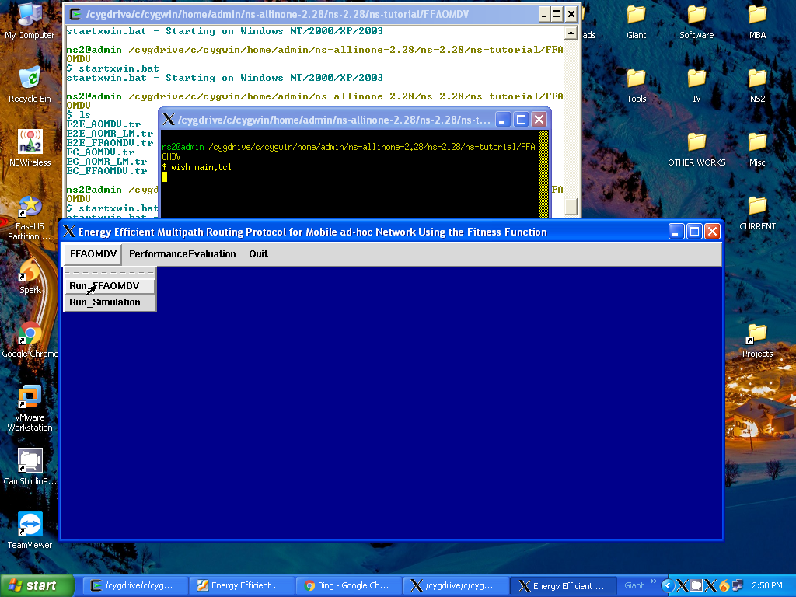

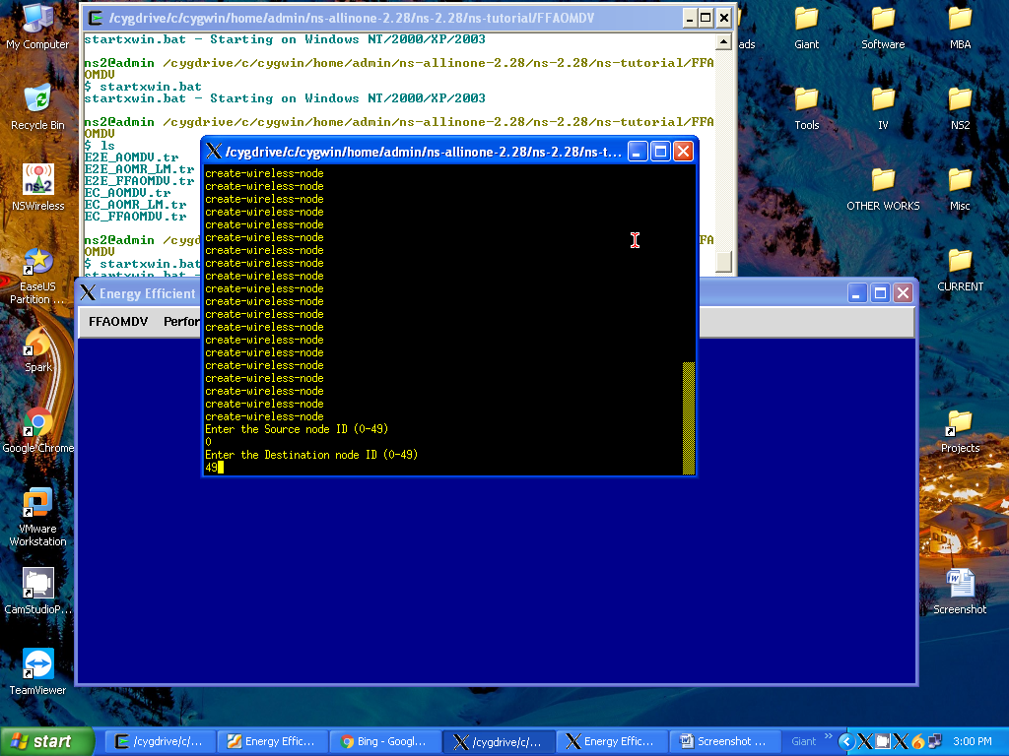

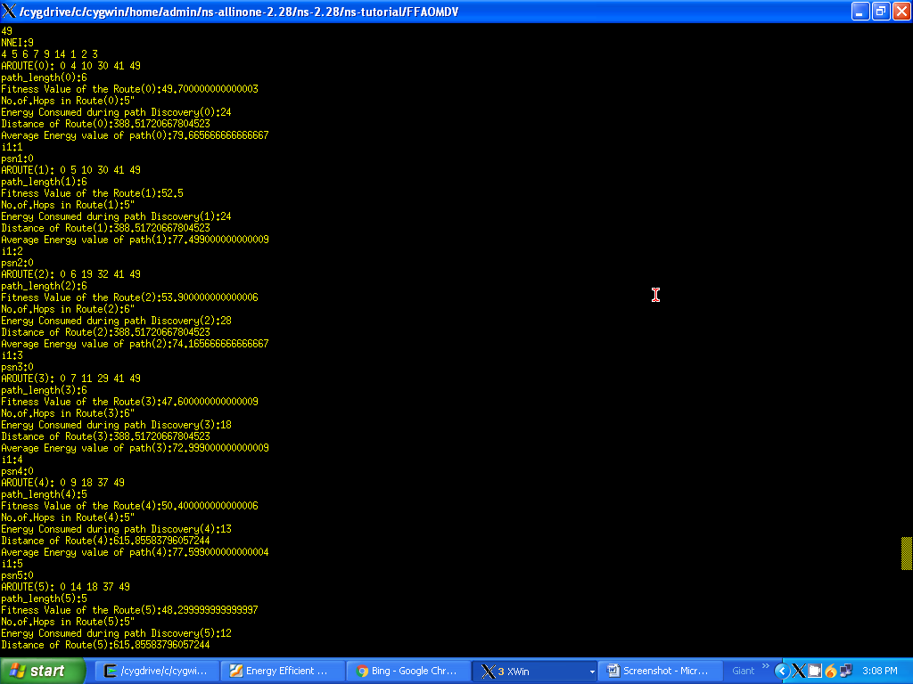

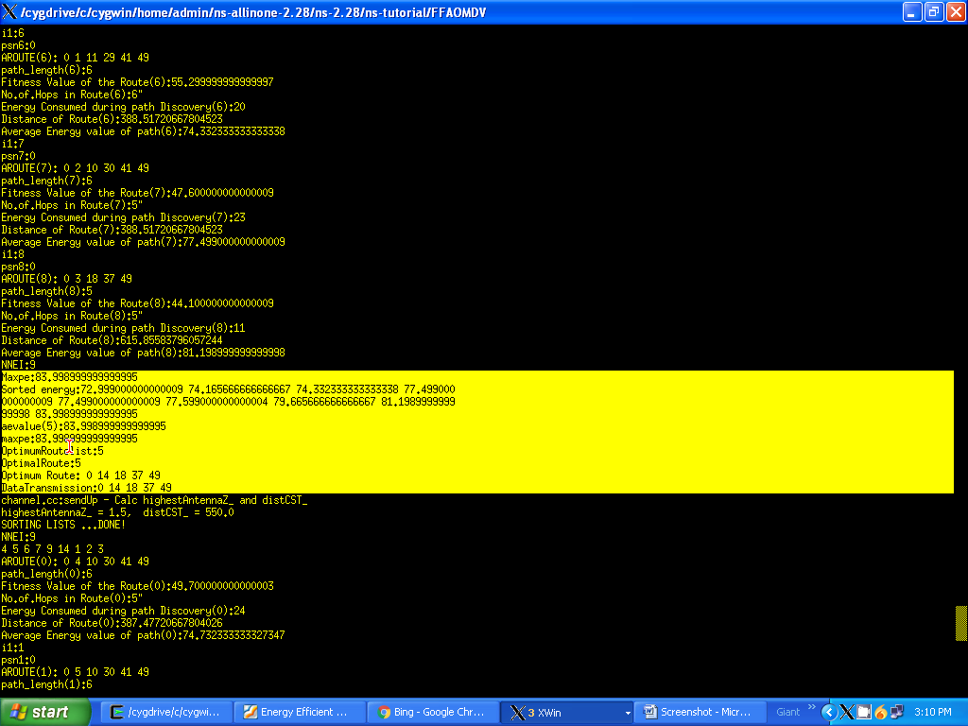

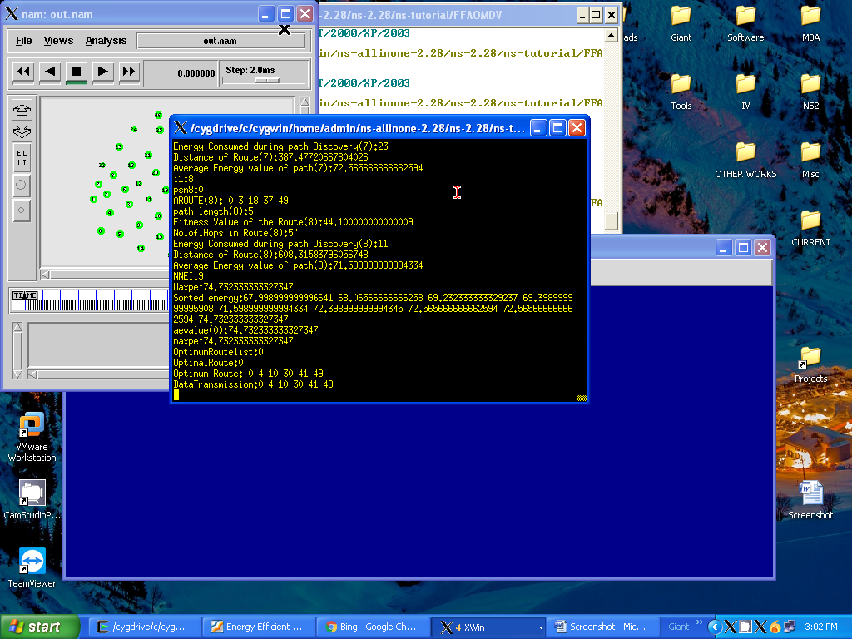

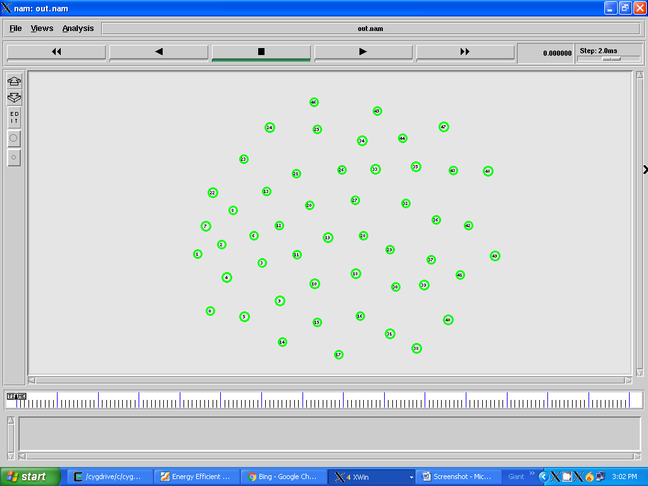

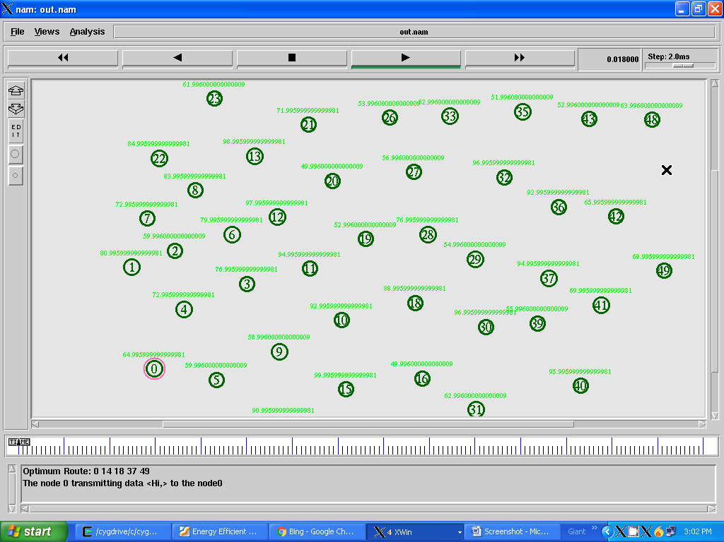

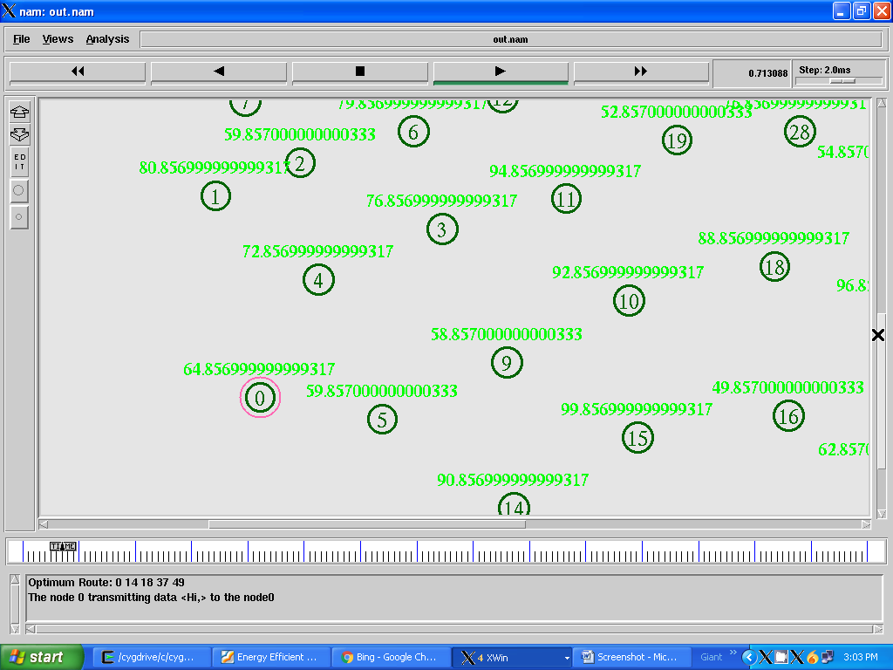

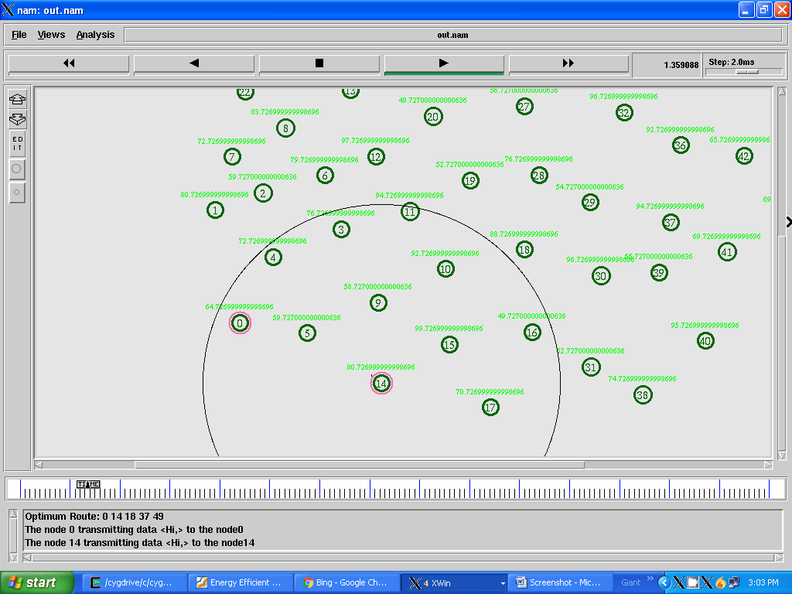

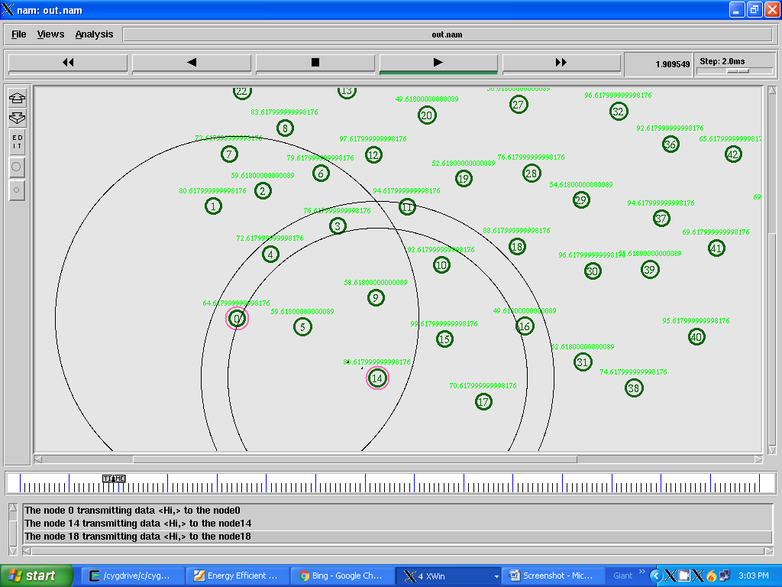

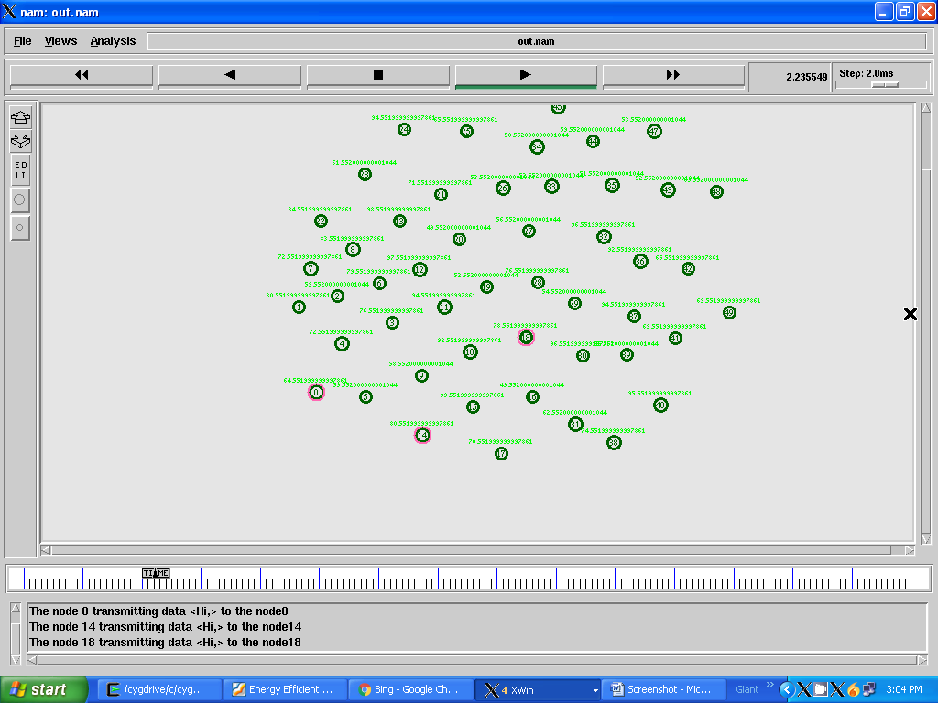

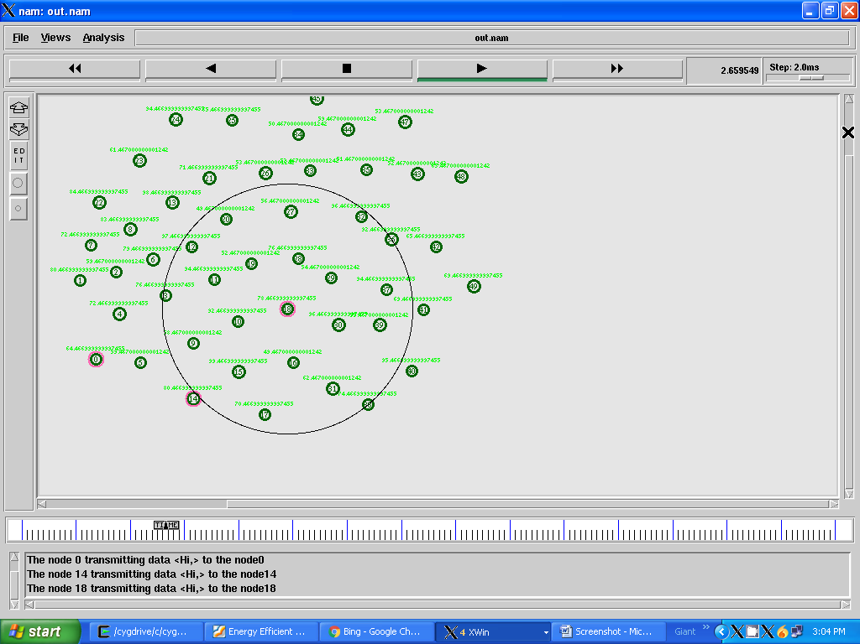

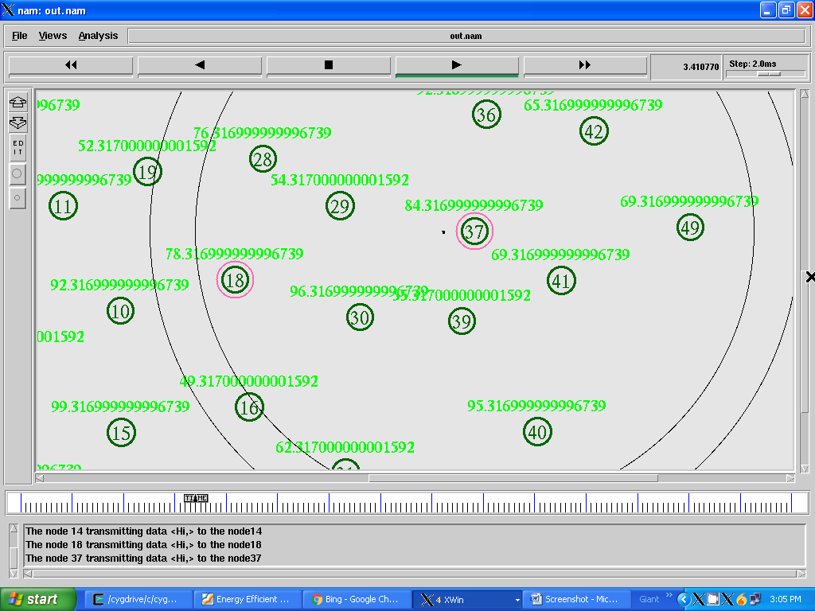

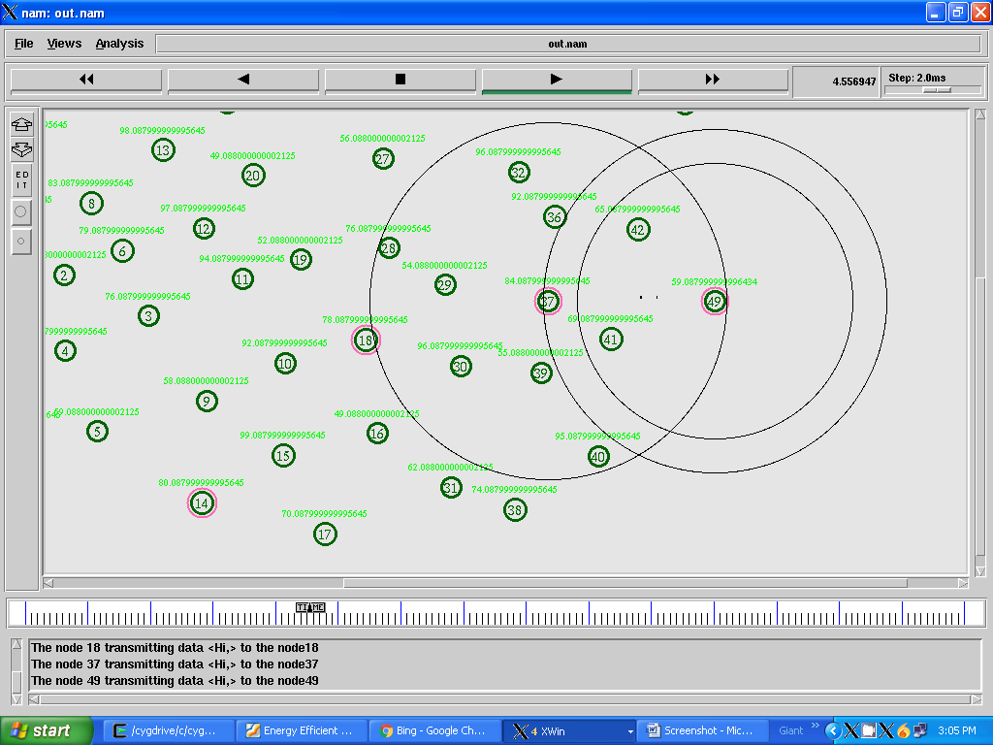

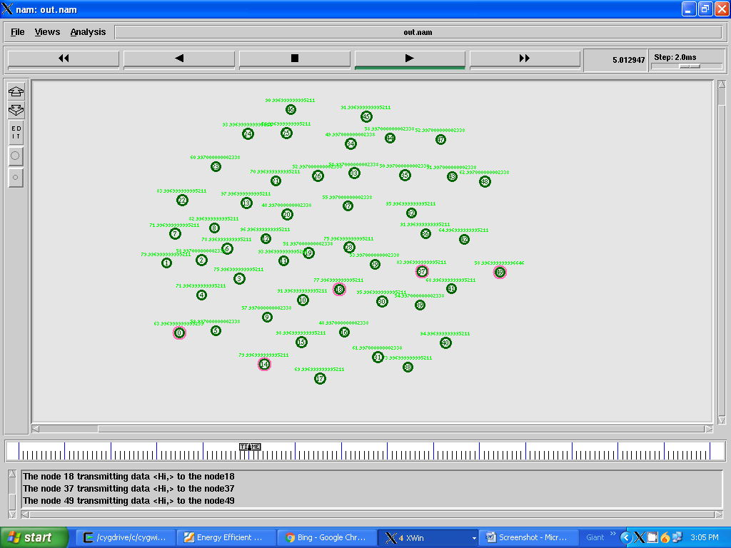

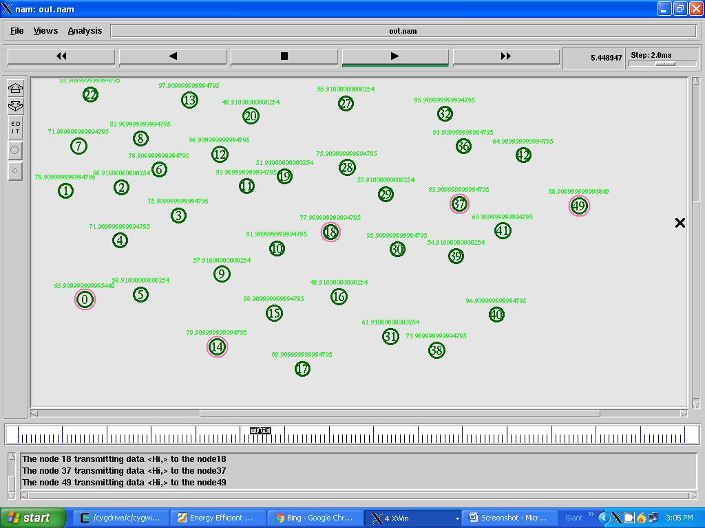

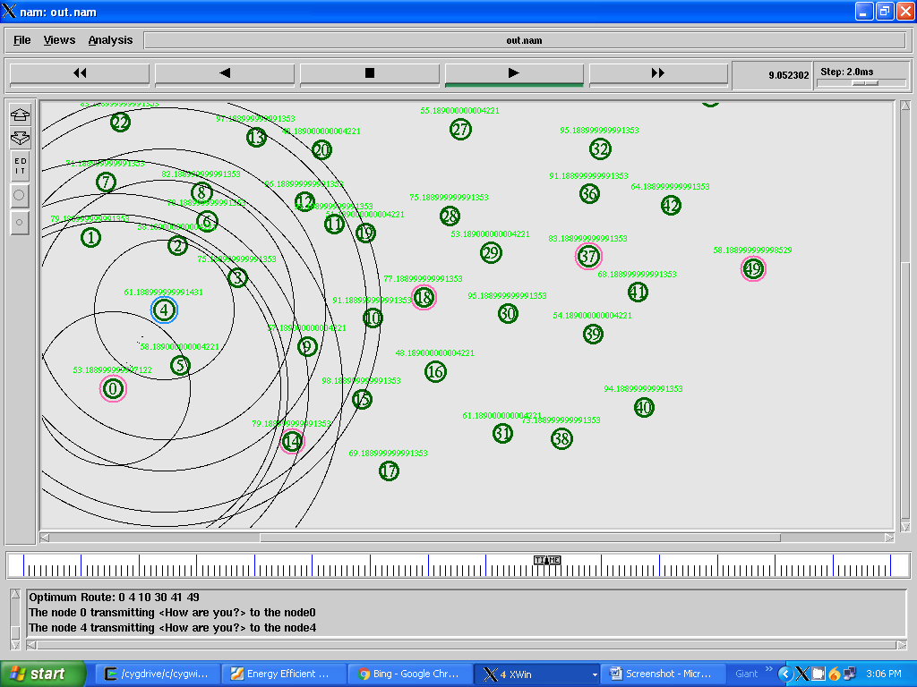

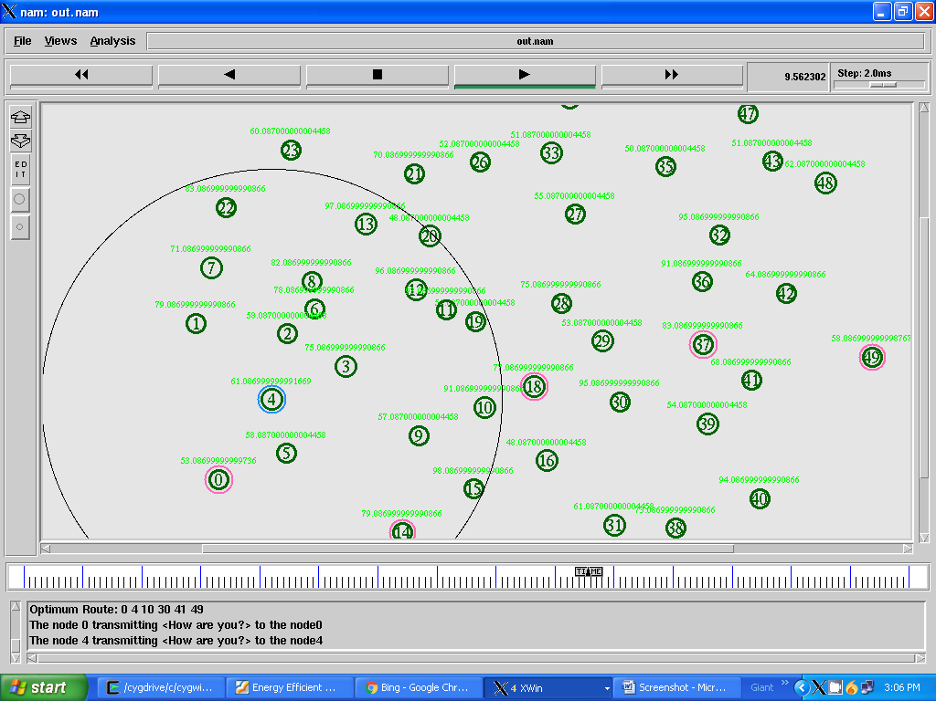

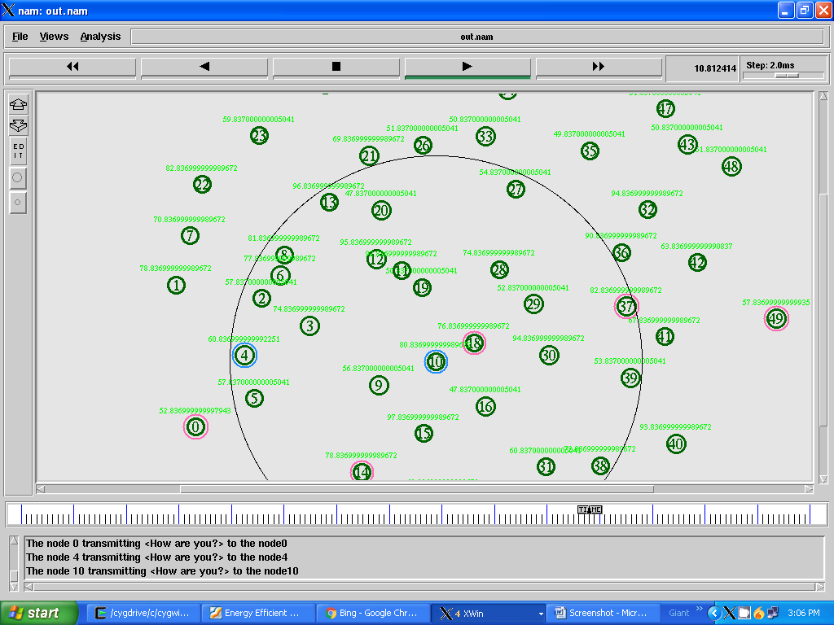

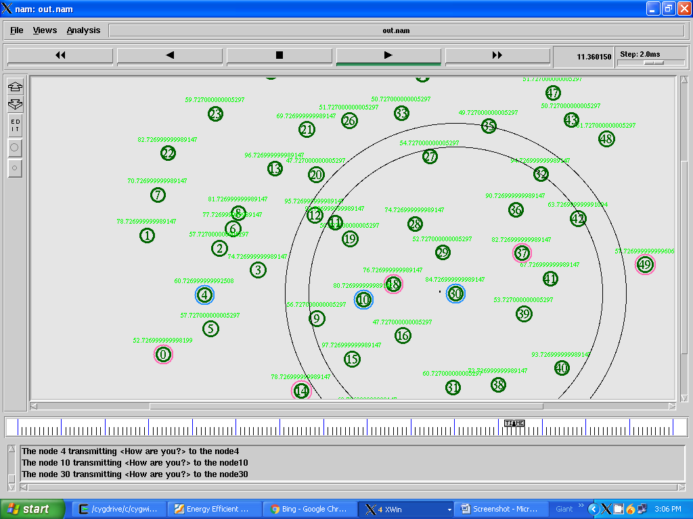

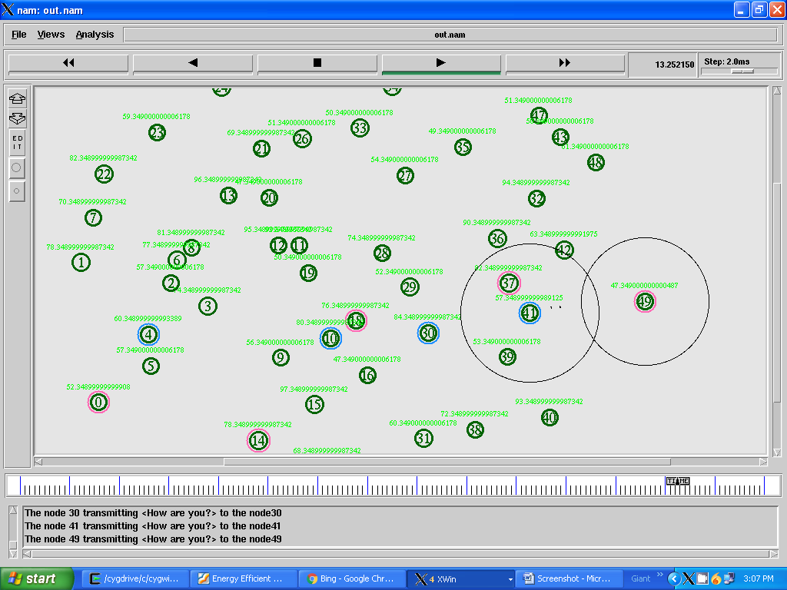

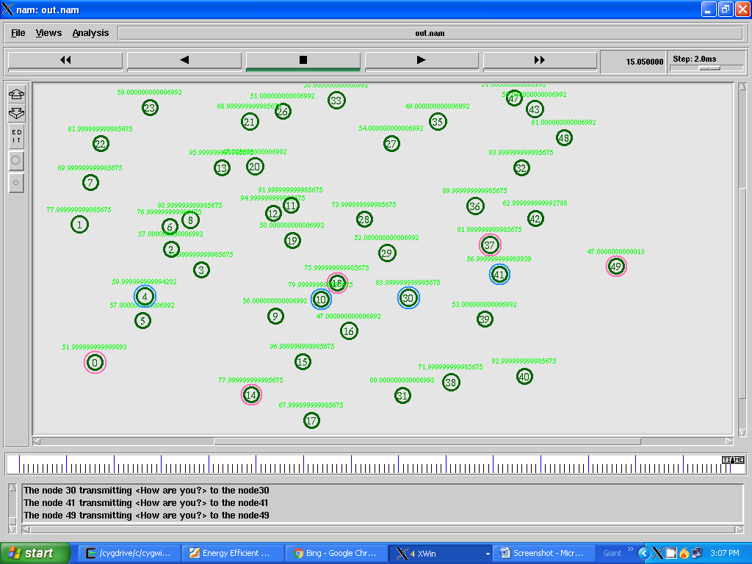

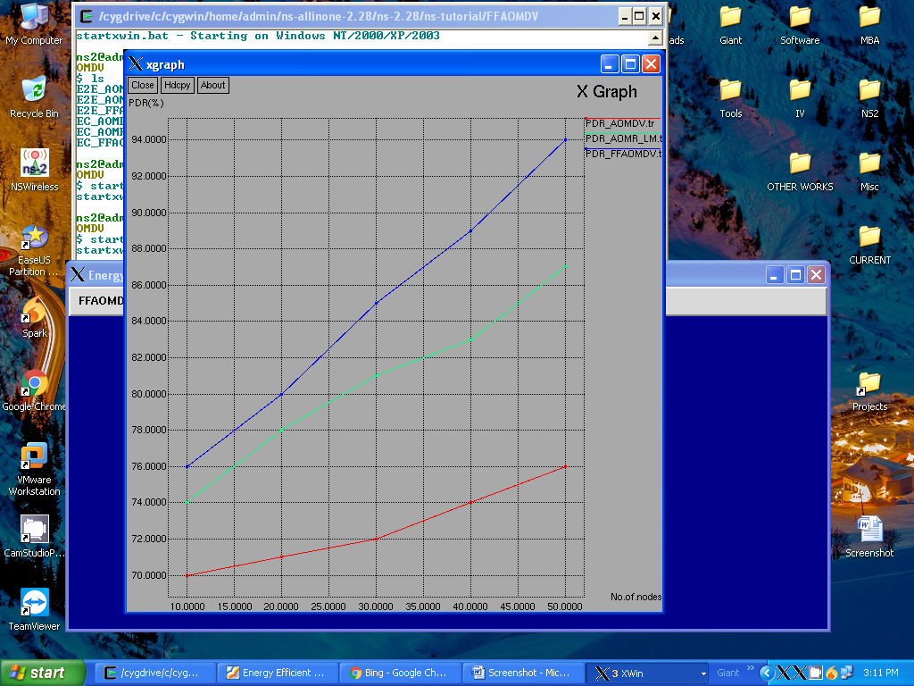

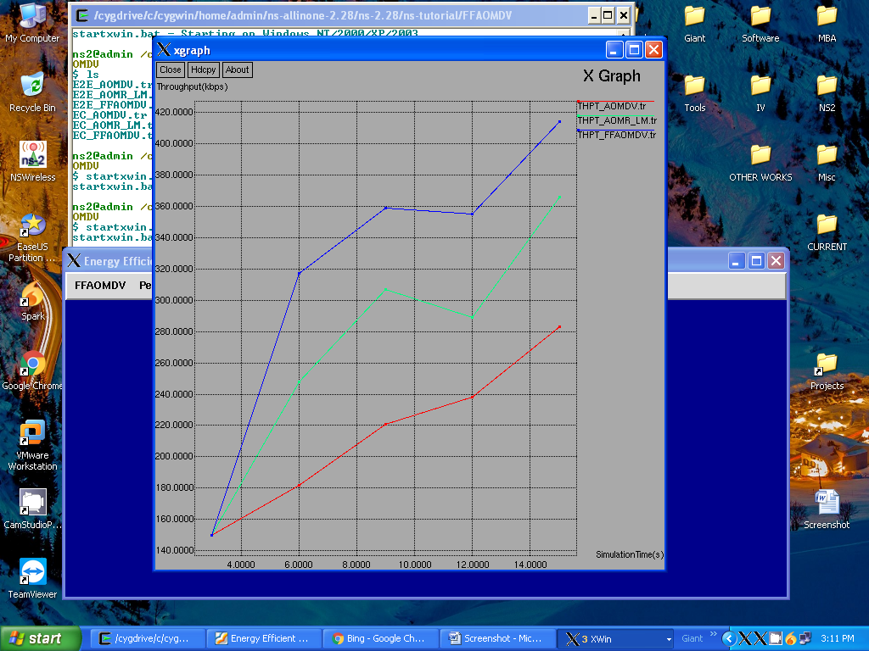

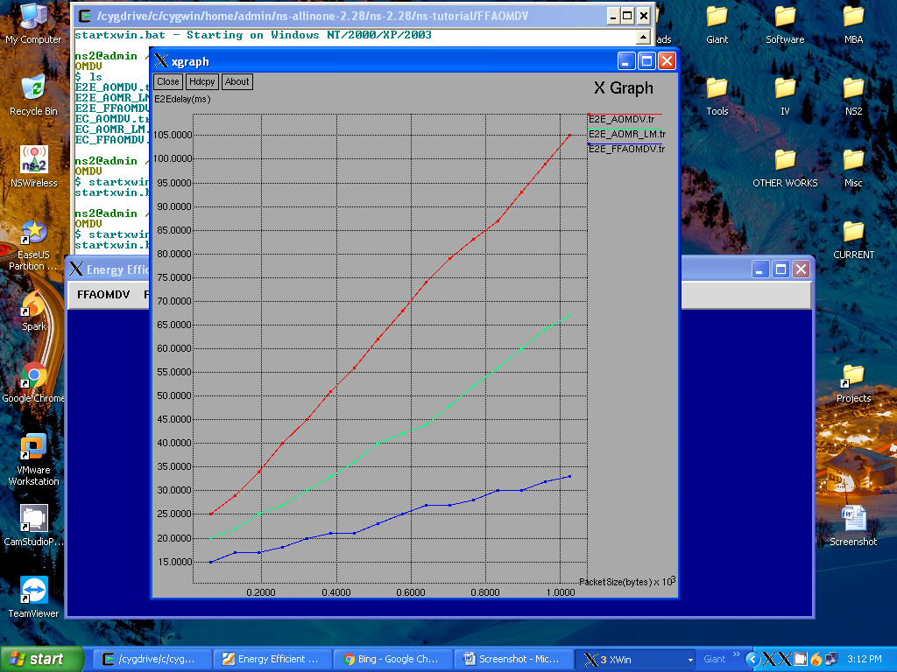

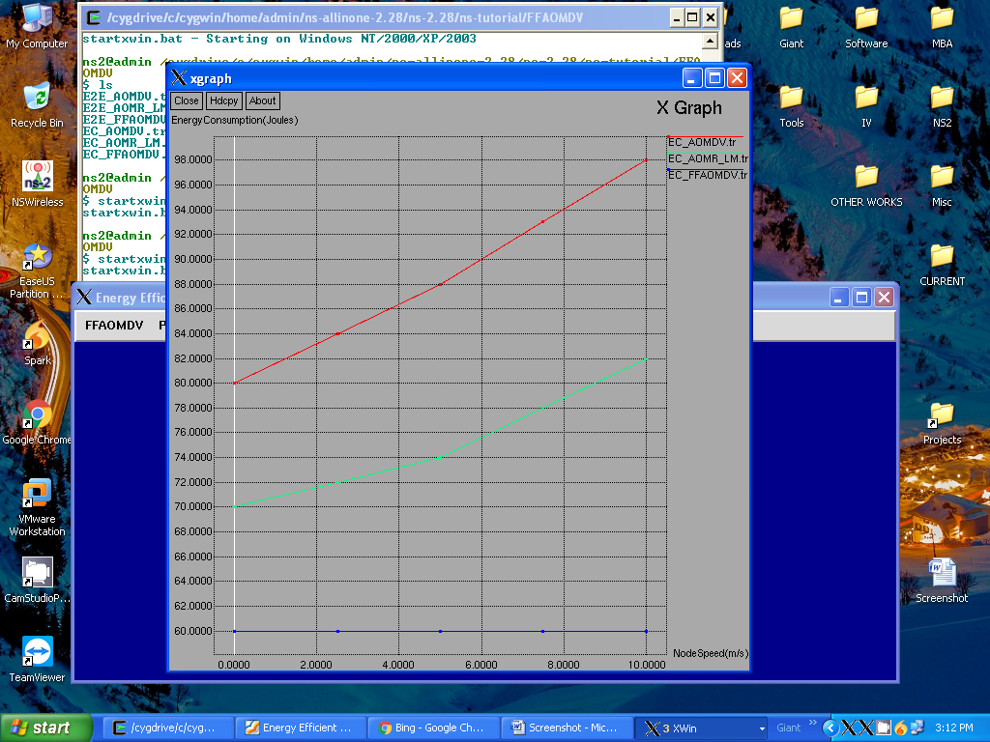

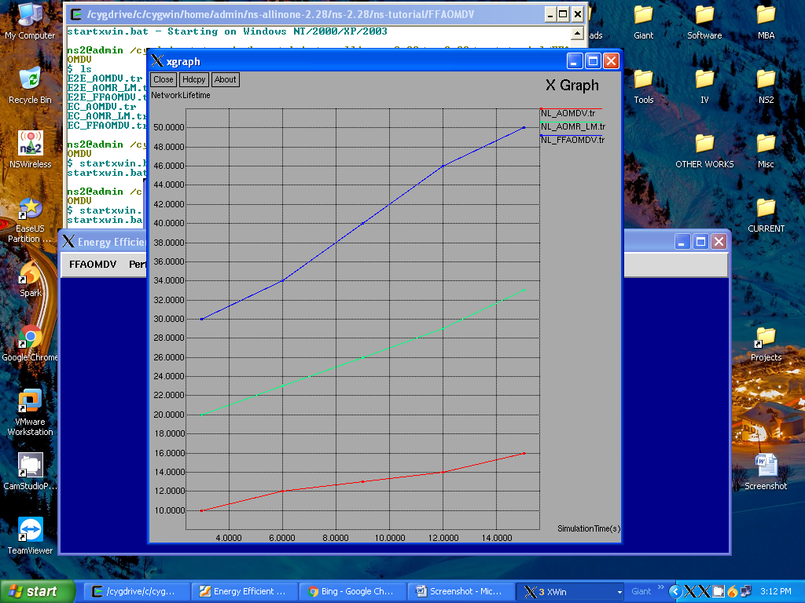

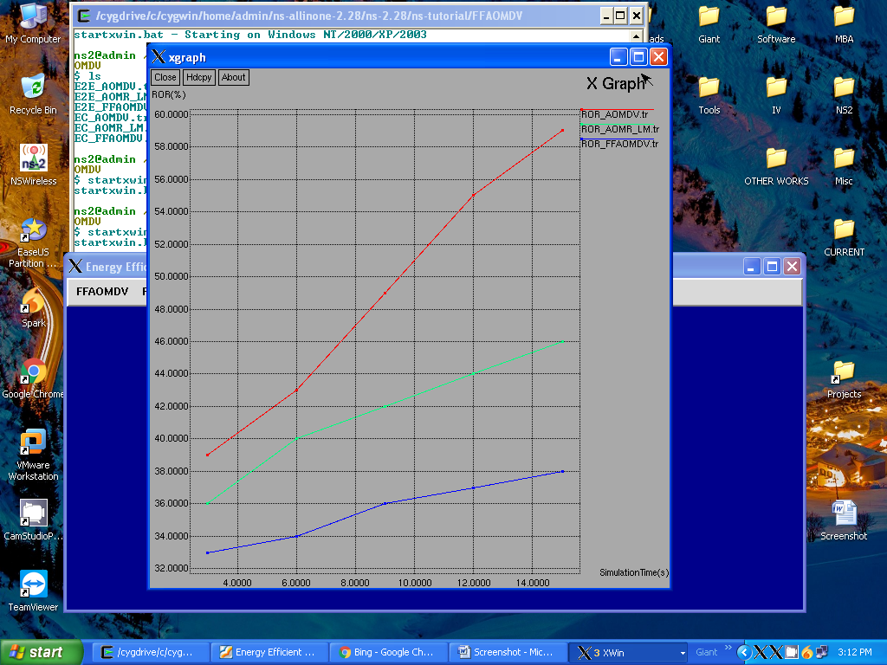

**APPENDIX 2**

**SAMPLE CODE:**

#===================================

#===================================

# Simulation parameters setup

#===================================

set val(chan) Channel/WirelessChannel ;# channel type

set val(prop) Propagation/TwoRayGround ;# radio-propagation model

set val(netif) Phy/WirelessPhy ;# network interface type

set val(mac) Mac/802_11 ;# MAC type

set val(ifq) Queue/DropTail/PriQueue ;# interface queue type

set val(ll) LL ;# link layer type

set val(ant) Antenna/OmniAntenna ;# antenna model

set val(ifqlen) 50 ;# max packet in ifq

set val(nn) 50 ;# number of mobilenodes

set val(rp) AODV ;# routing protocol

set val(x) 850 ;# X dimension of topography

set val(y) 670 ;# Y dimension of topography

set val(stop) 15.0 ;# time of simulation end

#===================================

# Initialization

#===================================

#Create a ns simulator

set ns [new Simulator]

#Setup topography object

set topo [new Topography]

$topo load_flatgrid $val(x) $val(y)

set god_ [create-god $val(nn)]

set nto [open NeighborTable.tr w]

$ns namtrace-all $nto

set rt [open RoutingTable.tr w]

$ns trace-all $rt

set dt_dnm1f [open PDR_AOMDV.tr w]

set dt_dnm1p2f [open PDR_AOMR_LM.tr w]

set dt_d1f [open PDR_FFAOMDV.tr w]

set dt_del1f [open THPT_AOMDV.tr w]

set dt_del2f [open THPT_AOMR_LM.tr w]

set dt_del3f [open THPT_FFAOMDV.tr w]

set dt_pc0f [open E2E_AOMDV.tr w]

set dt_pc0_1f [open E2E_AOMR_LM.tr w]

set dt_pc0_2f [open E2E_FFAOMDV.tr w]

set dift_pc0f [open EC_AOMDV.tr w]

set dift_pc0_1f [open EC_AOMR_LM.tr w]

set dift_pc0_2f [open EC_FFAOMDV.tr w]

set dt_t3d1f [open NL_AOMDV.tr w]

set dt_t2d1f [open NL_AOMR_LM.tr w]

set dt_t1d1f [open NL_FFAOMDV.tr w]

set dift_t3d1f [open ROR_AOMDV.tr w]

set dift_t2d1f [open ROR_AOMR_LM.tr w]

set dift_t1d1f [open ROR_FFAOMDV.tr w]

#Open the NS trace file

set tracefile [open out.tr w]

$ns trace-all $tracefile

#Open the NAM trace file

set namfile [open out.nam w]

$ns namtrace-all $namfile

$ns namtrace-all-wireless $namfile $val(x) $val(y)

set chan [new $val(chan)];#Create wireless channel

#===================================

# Mobile node parameter setup

#===================================

$ns node-config -adhocRouting $val(rp) \

-llType $val(ll) \

-macType $val(mac) \

-ifqType $val(ifq) \

-ifqLen $val(ifqlen) \

-antType $val(ant) \

-propType $val(prop) \

-phyType $val(netif) \

-channel $chan \

-topoInstance $topo \

-energyModel "EnergyModel" \

-idlePower 0.001 \

-rxPower 0.01 \

-txPower 0.02 \

-initialEnergy 100 \

-agentTrace ON \

-routerTrace ON \

-macTrace ON \

-movementTrace ON

#===================================

# Nodes Definition

#===================================

#Create 50 nodes

set n(0) [$ns node]

$n(0) set X_ 131

$n(0) set Y_ 119

$n(0) set Z_ 0.0

$ns initial_node_pos $n(0) 20

set n(1) [$ns node]

$n(1) set X_ 100

$n(1) set Y_ 259

$n(1) set Z_ 0.0

$ns initial_node_pos $n(1) 20

set n(2) [$ns node]

$n(2) set X_ 159

$n(2) set Y_ 282

$n(2) set Z_ 0.0

$ns initial_node_pos $n(2) 20

set n(3) [$ns node]

$n(3) set X_ 258

$n(3) set Y_ 236

$n(3) set Z_ 0.0

$ns initial_node_pos $n(3) 20

set n(4) [$ns node]

$n(4) set X_ 172

$n(4) set Y_ 201

$n(4) set Z_ 0.0

$ns initial_node_pos $n(4) 20

set n(5) [$ns node]

$n(5) set X_ 216

$n(5) set Y_ 104

$n(5) set Z_ 0.0

$ns initial_node_pos $n(5) 20

set n(6) [$ns node]

$n(6) set X_ 238

$n(6) set Y_ 304

$n(6) set Z_ 0.0

$ns initial_node_pos $n(6) 20

set n(7) [$ns node]

$n(7) set X_ 121

$n(7) set Y_ 326

$n(7) set Z_ 0.0

$ns initial_node_pos $n(7) 20

set n(8) [$ns node]

$n(8) set X_ 187

$n(8) set Y_ 365

$n(8) set Z_ 0.0

$ns initial_node_pos $n(8) 20

set n(9) [$ns node]

$n(9) set X_ 303

$n(9) set Y_ 143

$n(9) set Z_ 0.0

$ns initial_node_pos $n(9) 20

set n(10) [$ns node]

$n(10) set X_ 388

$n(10) set Y_ 186

$n(10) set Z_ 0.0

$ns initial_node_pos $n(10) 20

set n(11) [$ns node]

$n(11) set X_ 344

$n(11) set Y_ 257

$n(11) set Z_ 0.0

$ns initial_node_pos $n(11) 20

set n(12) [$ns node]

$n(12) set X_ 300

$n(12) set Y_ 328

$n(12) set Z_ 0.0

$ns initial_node_pos $n(12) 20

set n(13) [$ns node]

$n(13) set X_ 269

$n(13) set Y_ 412

$n(13) set Z_ 0.0

$ns initial_node_pos $n(13) 20

set n(14) [$ns node]

$n(14) set X_ 308

$n(14) set Y_ 42

$n(14) set Z_ 0.0

$ns initial_node_pos $n(14) 20

set n(15) [$ns node]

$n(15) set X_ 394

$n(15) set Y_ 91

$n(15) set Z_ 0.0

$ns initial_node_pos $n(15) 20

set n(16) [$ns node]

$n(16) set X_ 499

$n(16) set Y_ 106

$n(16) set Z_ 0.0

$ns initial_node_pos $n(16) 20

set n(17) [$ns node]

$n(17) set X_ 446

$n(17) set Y_ 12

$n(17) set Z_ 0.0

$ns initial_node_pos $n(17) 20

set n(18) [$ns node]

$n(18) set X_ 489

$n(18) set Y_ 210

$n(18) set Z_ 0.0

$ns initial_node_pos $n(18) 20

set n(19) [$ns node]

$n(19) set X_ 421

$n(19) set Y_ 298

$n(19) set Z_ 0.0

$ns initial_node_pos $n(19) 20

set n(20) [$ns node]

$n(20) set X_ 375

$n(20) set Y_ 378

$n(20) set Z_ 0.0

$ns initial_node_pos $n(20) 20

set n(21) [$ns node]

$n(21) set X_ 342

$n(21) set Y_ 455

$n(21) set Z_ 0.0

$ns initial_node_pos $n(21) 20

set n(22) [$ns node]

$n(22) set X_ 138

$n(22) set Y_ 409

$n(22) set Z_ 0.0

$ns initial_node_pos $n(22) 20

set n(23) [$ns node]

$n(23) set X_ 213

$n(23) set Y_ 491

$n(23) set Z_ 0.0

$ns initial_node_pos $n(23) 20

set n(24) [$ns node]

$n(24) set X_ 278

$n(24) set Y_ 569

$n(24) set Z_ 0.0

$ns initial_node_pos $n(24) 20

set n(25) [$ns node]

$n(25) set X_ 394

$n(25) set Y_ 564

$n(25) set Z_ 0.0

$ns initial_node_pos $n(25) 20

set n(26) [$ns node]

$n(26) set X_ 454

$n(26) set Y_ 465

$n(26) set Z_ 0.0

$ns initial_node_pos $n(26) 20

set n(27) [$ns node]

$n(27) set X_ 487

$n(27) set Y_ 390

$n(27) set Z_ 0.0

$ns initial_node_pos $n(27) 20

set n(28) [$ns node]

$n(28) set X_ 507

$n(28) set Y_ 304

$n(28) set Z_ 0.0

$ns initial_node_pos $n(28) 20

set n(29) [$ns node]

$n(29) set X_ 572

$n(29) set Y_ 270

$n(29) set Z_ 0.0

$ns initial_node_pos $n(29) 20

set n(30) [$ns node]

$n(30) set X_ 586

$n(30) set Y_ 177

$n(30) set Z_ 0.0

$ns initial_node_pos $n(30) 20

set n(31) [$ns node]

$n(31) set X_ 573

$n(31) set Y_ 63

$n(31) set Z_ 0.0

$ns initial_node_pos $n(31) 20

set n(32) [$ns node]

$n(32) set X_ 611

$n(32) set Y_ 383

$n(32) set Z_ 0.0

$ns initial_node_pos $n(32) 20

set n(33) [$ns node]

$n(33) set X_ 537

$n(33) set Y_ 467

$n(33) set Z_ 0.0

$ns initial_node_pos $n(33) 20

set n(34) [$ns node]

$n(34) set X_ 505

$n(34) set Y_ 536

$n(34) set Z_ 0.0

$ns initial_node_pos $n(34) 20

set n(35) [$ns node]

$n(35) set X_ 637

$n(35) set Y_ 473

$n(35) set Z_ 0.0

$ns initial_node_pos $n(35) 20

set n(36) [$ns node]

$n(36) set X_ 686

$n(36) set Y_ 342

$n(36) set Z_ 0.0

$ns initial_node_pos $n(36) 20

set n(37) [$ns node]

$n(37) set X_ 673

$n(37) set Y_ 244

$n(37) set Z_ 0.0

$ns initial_node_pos $n(37) 20

set n(38) [$ns node]

$n(38) set X_ 638

$n(38) set Y_ 27

$n(38) set Z_ 0.0

$ns initial_node_pos $n(38) 20

set n(39) [$ns node]

$n(39) set X_ 657

$n(39) set Y_ 182

$n(39) set Z_ 0.0

$ns initial_node_pos $n(39) 20

set n(40) [$ns node]

$n(40) set X_ 716

$n(40) set Y_ 96

$n(40) set Z_ 0.0

$ns initial_node_pos $n(40) 20

set n(41) [$ns node]

$n(41) set X_ 745

$n(41) set Y_ 207

$n(41) set Z_ 0.0

$ns initial_node_pos $n(41) 20

set n(42) [$ns node]

$n(42) set X_ 765

$n(42) set Y_ 329

$n(42) set Z_ 0.0

$ns initial_node_pos $n(42) 20

set n(43) [$ns node]

$n(43) set X_ 728

$n(43) set Y_ 463

$n(43) set Z_ 0.0

$ns initial_node_pos $n(43) 20

set n(44) [$ns node]

$n(44) set X_ 603

$n(44) set Y_ 543

$n(44) set Z_ 0.0

$ns initial_node_pos $n(44) 20

set n(45) [$ns node]

$n(45) set X_ 541

$n(45) set Y_ 609

$n(45) set Z_ 0.0

$ns initial_node_pos $n(45) 20

set n(46) [$ns node]

$n(46) set X_ 386

$n(46) set Y_ 632

$n(46) set Z_ 0.0

$ns initial_node_pos $n(46) 20

set n(47) [$ns node]

$n(47) set X_ 705

$n(47) set Y_ 570

$n(47) set Z_ 0.0

$ns initial_node_pos $n(47) 20

set n(48) [$ns node]

$n(48) set X_ 814

$n(48) set Y_ 462

$n(48) set Z_ 0.0

$ns initial_node_pos $n(48) 20

set n(49) [$ns node]

$n(49) set X_ 831

$n(49) set Y_ 254

$n(49) set Z_ 0.0

$ns initial_node_pos $n(49) 20

#Random Waypoint Model

source mobility50

for {set i 0} {$i<$val(nn)} {incr i} {

$n($i) color yellowgreen

$ns at 0.0 "$n($i) color darkgreen"

}

# for {set i 0} {$i<$val(nn)} {incr i} {

# $ns at 0.0 "$n($i) add-mark m1 darkgreen"

# }

#Random Generation

proc myRand { min max } {

set maxFactor [expr [expr $max + 1] - $min]

set value [expr int([expr rand() * 100])]

set value [expr [expr $value % $maxFactor] + $min]

return $value

}

proc lrandom L {

lindex $L [expr {int(rand()*[llength $L])}]

}

#===================================

# Energy Model

#===================================

# Initial Energy

for {set i 0} {$i<$val(nn)} {incr i} {

set energy($i) [myRand 50 100]

}

proc myRand { min max } {

set maxFactor [expr [expr $max + 1] - $min]

set value [expr int([expr rand() * 100])]

set value [expr [expr $value % $maxFactor] + $min]

return $value

}

proc sleepPower {node} {

global array names energy ns array names n

set ti 0.005

set energy($node) [expr $energy($node)-0.001]

$ns at [$ns now] "$n($node) label $energy($node)"

$ns at [expr [$ns now]+$ti] "sleepPower $node"

}

proc activeMode {node} {

global array names energy ns array names n

set energy($node) [expr $energy($node)-10.0]

$ns at [$ns now] "$n($node) label $energy($node)"

}

for {set i 0} {$i<$val(nn)} {incr i} {

sleepPower $i

}

#Multiple Paths

puts "Enter the Source node ID (0-49)"

set sn [gets stdin]

$ns at [$ns now] "$n($sn) label Source"

puts "Enter the Destination node ID (0-49)"

set dn [gets stdin]

$ns at [$ns now] "$n($dn) label Destination"

puts "Enter the Data1 to Transmit"

set data1 [gets stdin]

puts "Enter the Data2 to Transmit"

set data2 [gets stdin]

set bestpath 0

set nhibp 0

set c(1) hotpink

set c(2) dodgerblue

set ci 1

# Neighbor Selection Algorithm

set communicationrange 250

for {set i 0} {$i<$val(nn)} {incr i} {

set NL($i) [list]

set xpos1 [$n($i) set X_]

set ypos1 [$n($i) set Y_]

for {set j 0} {$j<$val(nn)} {incr j} {

if {$i!=$j} {

set xpos2 [$n($j) set X_]

set ypos2 [$n($j) set Y_]

set xpos [expr $xpos1-$xpos2]

set ypos [expr $ypos1-$ypos2]

set kv [expr $xpos*$xpos+$ypos*$ypos]

set d [expr sqrt($kv)]

set nd($i,$j) $d

puts "Distance from $i to $j : $d"

if {$d<$communicationrange} {

$n($i) add-neighbor $n($j)

}

}

}

set neighbor1 [$n($i) neighbors]

foreach nb1 $neighbor1 {

set now [$ns now]

puts "The neighbor for node $i are: $nb1"

set idv [$nb1 id]

puts "$idv"

lappend NL($i) $idv

}

puts $nto "$i $NL($i)"

}

#Available Route estimation

puts $rt "~~~~~~~~~~~~~~~~~~~~~~~~~~~~~~~~~~~~~~~~~~~~~~~~~~~~~~~~~~~~~~~~~~"

puts $rt "RouteFrom RouteTo Route"

puts $rt "~~~~~~~~~~~~~~~~~~~~~~~~~~~~~~~~~~~~~~~~~~~~~~~~~~~~~~~~~~~~~~~~~~"

for {set des 0} {$des<$val(nn)} {incr des} {

for {set j 0} {$j<$val(nn)} {incr j} {

if {$des!=$j} {

lappend route($j,$des) $j

set s $j

set flag 0

set RN $s

puts "Route from $j to $des"

while {$RN!=$des} {

puts "RN:$RN"

foreach rn $NL($RN) {

if {$rn==$des} {

set flag 1

}

}

if {$flag==1} {

set RN1 $des

} else {

set x_pos1 [$n($des) set X_]

set y_pos1 [$n($des) set Y_]

set dL [list]

foreach rnod $NL($RN) {

set x_pos2 [$n($rnod) set X_]

set y_pos2 [$n($rnod) set Y_]

set x_pos [expr $x_pos1-$x_pos2]

set y_pos [expr $y_pos1-$y_pos2]

set v [expr $x_pos*$x_pos+$y_pos*$y_pos]

set D2 [expr sqrt($v)]

lappend dL $D2

set dis($des,$rnod) $D2

}

set dis1 [lsort -real $dL]

set mindis [lindex $dis1 0]

set mindis1 [lindex $dis1 1]

foreach i $NL($RN) {

if {$i!=$des} {

if {$mindis==$dis($des,$i)} {

set RN1 $i

}

}

}

foreach i1 $NL($RN) {

if {$i1!=$des} {

if {$mindis1==$dis($des,$i1)} {

set ANode(RN1) $i1

}

}

}

}

set RN $RN1

lappend route($j,$des) $RN

puts "$RN"

}

puts $rt "$j $des $route($j,$des)"

}

}

}

#===================================

# Agents Definition

#===================================

proc attach-cbr-traffic {node sink size interval} {

global ns

set source [new Agent/UDP]

$source set class_ 2

$ns attach-agent $node $source

set traffic [new Application/Traffic/CBR]

$traffic set packetSize_ $size

$traffic set interval_ $interval

$traffic attach-agent $source

$ns connect $source $sink

return $traffic

}

set time 0.0

set DCv [myRand 5 20]

#Packet Queue

for {set i 0} {$i<$val(nn)} {incr i} {

set packet_counter [myRand 5 20]

set DC($i) [expr 0.1*$DCv*$packet_counter]

}

for {set i 0} {$i<$val(nn)} {incr i} {

set packet_numbers_in_waiting_list [myRand 1 50]

set Cv($i) [myRand 1 7]

set Amount_of_Buffer $val(ifqlen)

set LB($i) [expr 1-($packet_numbers_in_waiting_list/$Amount_of_Buffer)]

}

proc FFAOMDV {} {

global array names DC array names Cv array names LB array names nd array names c ci psn nnei nhibp array names n ns sn dn array names NL array names aroute array names route array names energy

set i1 0

set isdn 0

set tp 10

foreach nein $NL($sn) {

if {$nein==$dn} {

set pos [lsearch $NL($sn) $nein]

set NL($sn) [lreplace $NL($sn) $ $pos]

set aroute($i1) [list]

lappend aroute($i1) $sn

lappend aroute($i1) $dn

set isdn 1

set path_length($i1) [llength $aroute($i1)]

puts "path_length($i1):$path_length($i1)"

set tpe($i1) 0

#FitnessValue

set DC_Route($i1) 0

foreach in1 $aroute($i1) {

set DC_Route($i1) [expr $DC_Route($i1)+$DC($in1)]

}

puts "Fitness Value of the Route($i1):$DC_Route($i1)"

#No.of.hops

set LB_Route($i1) 0

foreach in2 $aroute($i1) {

set LB_Route($i1) [expr $LB_Route($i1)+$LB($in2)]

}

puts "No.of.Hops in Route($i1):$LB_Route($i1)\""

#EnergyConsumed

set Conv_Route($i1) 0

foreach in3 $aroute($i1) {

set Conv_Route($i1) [expr $Conv_Route($i1)+$Cv($in3)]

}

puts "Energy Consumed during path Discovery($i1):$Conv_Route($i1)"

#

foreach in5 $aroute($i1) {

if {$in5!=$dn} {

set TC($in5) [expr $nd($in5,$dn)*$tp]

#puts "The TC($in5):$TC($in5)\""

}

}

#Distance

set alpha 0.35

set PC_Route($i1) 0

foreach in4 $aroute($i1) {

if {$in4!=$dn} {

set BR($in4) $energy($in4)

set PC_Route($i1) [expr $alpha*$TC($in4)+(1-$alpha)*$BR($in4)]

}

}

puts "Distance of Route($i1):$PC_Route($i1)\""

foreach inode $aroute($i1) {

set tpe($i1) [expr $tpe($i1)+$energy($inode)]

}

set aevalue($i1) [expr $tpe($i1)/$path_length($i1)]

lappend aevl $aevalue($i1)

incr i1

}

}

set nnei [llength $NL($sn)]

puts "NNEI:$nnei"

puts "$NL($sn)"

set nnei1 $nnei

for {set i 0} {$i<$nnei} {incr i} {

if {$i>0} {

if {$psn == 0} {

incr i1

puts i1:$i1

puts "psn$i:$psn"

}

if {$psn == 1} {

set i1 $i1

puts i1minus:$i1

puts "psn$i:$psn"

}

}

set NRn [lindex $NL($sn) $i]

if {$NRn!=$dn} {

set psn 0

foreach rnv $route($NRn,$dn) {

if {$rnv==$sn || $energy($rnv)<10} {

set psn 1

puts "Energy($rnv):$energy($rnv)"

puts "source Psn:$psn"

set nnei1 [expr $nnei1-1]

}

}

if {$psn==0} {

set aroute($i1) [list]

lappend aroute($i1) $sn

foreach rnv1 $route($NRn,$dn) {

lappend aroute($i1) $rnv1

}

}

if {$psn==0} {

#$ns at [$ns now] "$ns trace-annotate \"Available route($i1): $aroute($i1)\""

puts "AROUTE($i1): $aroute($i1)"

set path_length($i1) [llength $aroute($i1)]

set tpe($i1) 0

set path_length($i1) [llength $aroute($i1)]

puts "path_length($i1):$path_length($i1)"

#FitnessValue

set DC_Route($i1) 0

foreach in1 $aroute($i1) {

set DC_Route($i1) [expr $DC_Route($i1)+$DC($in1)]

}

puts "Fitness Value of the Route($i1):$DC_Route($i1)"

#No.of.hops

set LB_Route($i1) 0

foreach in2 $aroute($i1) {

set LB_Route($i1) [expr $LB_Route($i1)+$LB($in2)]

}

puts "No.of.Hops in Route($i1):$LB_Route($i1)\""

#EnergyConsumed

set Conv_Route($i1) 0

foreach in3 $aroute($i1) {

set Conv_Route($i1) [expr $Conv_Route($i1)+$Cv($in3)]

}

puts "Energy Consumed during path Discovery($i1):$Conv_Route($i1)"

#

foreach in5 $aroute($i1) {

if {$in5!=$dn} {

set TC($in5) [expr $nd($in5,$dn)*$tp]

#$ns at [$ns now] "$ns trace-annotate \"The TC($in5):$TC($in5)\""

}

}

#Distance

set alpha 0.35

set PC_Route($i1) 0

foreach in4 $aroute($i1) {

if {$in4!=$dn} {

set BR($in4) $energy($in4)

set PC_Route($i1) [expr $alpha*$TC($in4)+(1-$alpha)*$BR($in4)]

}

}

puts "Distance of Route($i1):$PC_Route($i1)"

foreach inode $aroute($i1) {

set tpe($i1) [expr $tpe($i1)+$energy($inode)]

}

#$ns at [$ns now] "$ns trace-annotate \"Average Energy value of path($i1):$aevalue($i1)\""

}

}

}

if {$isdn==1} {

set nnei1 [expr $nnei1+1]

puts "NNEI:$nnei1"

}

puts "NNEI:$nnei1"

set sel [lsort -real $aevl]

set maxpe [lindex $sel end]

puts "Maxpe:$maxpe"

puts "Sorted energy:$sel"

set bpl [list]

for {set i 0} {$i<$nnei1} {incr i} {

if {$aevalue($i)==$maxpe} {

puts "aevalue($i):$aevalue($i)"

puts "maxpe:$maxpe"

lappend bpl $i

}

}

set nbp [llength $bpl]

puts "OptimumRoutelist:$bpl"

if {$nbp>1} {

foreach bpi $bpl {

lappend nhbp $path_length($bpi)

}

set sl [lsort -integer $nhbp]

set minnh [lindex $sl 0]

foreach bpi1 $bpl {

if {$minnh==$path_length($bpi1)} {

set bestpath $bpi1

puts "OptimalRoute:$bestpath"

}

}

} else {

foreach bpi2 $bpl {

set bestpath $bpi2

puts "OptimalRoute:$bestpath"

}

}

puts "Optimum Route: $aroute($bestpath)"

set nhibp $path_length($bestpath)

$ns at [$ns now] "$ns trace-annotate \"Optimum Route: $aroute($bestpath)\""

$ns at [$ns now] "DataTransmission $bestpath $c($ci)"

incr ci

}

$ns at 0.0 "FFAOMDV"

# $ns at 0.5 "DataTransmission"

$ns at 8.0 "FFAOMDV"

# $ns at 8.5 "DataTransmission"

set null [new Agent/LossMonitor]

proc DataTransmission {bp colorval} {

global ns array names n sn null array names aroute data1 data2

set time [$ns now]

set snode $sn

puts "DataTransmission:$aroute($bp)"

foreach rnode $aroute($bp) {

$ns attach-agent $n($rnode) $null

set cbr4 [attach-cbr-traffic $n($snode) $null 100 0.05]

$ns at $time "$n($rnode) add-mark m5 $colorval"

if {$time<5.0} {

$ns at $time "$ns trace-annotate \"The node $rnode transmitting data <$data1> to the node$rnode\""

} else {

$ns at $time "$ns trace-annotate \"The node $rnode transmitting <$data2> to the node$rnode\""

}

$ns at $time "activeMode $rnode"

$ns at $time "$cbr4 start"

$ns at [expr $time+1.0] "$cbr4 stop"

set time [expr $time+1.0]

set snode $rnode

}

}

#Performance Evaluation

set nnodes 10

set dt_DeqNm1 70

set dt_DeqNm1p2 74

set dt_Deq1 76

while {$nnodes<=50} {

puts $dt_dnm1f "$nnodes $dt_DeqNm1"

puts $dt_dnm1p2f "$nnodes $dt_DeqNm1p2"

puts $dt_d1f "$nnodes $dt_Deq1"

set dt_DeqNm1 [expr $dt_DeqNm1+[myRand 0 2]]

set dt_DeqNm1p2 [expr $dt_DeqNm1p2+[myRand 2 4]]

set dt_Deq1 [expr $dt_Deq1+[myRand 4 6]]

set nnodes [expr $nnodes+10]

}

set dt_del1 150

set dt_del2 150

set dt_del3 150

set simulation 3

while {$simulation<=15} {

puts $dt_del1f "$simulation $dt_del1"

puts $dt_del2f "$simulation $dt_del2"

puts $dt_del3f "$simulation $dt_del3"

set dt_del1 [expr $dt_del1+[myRand 0 50]]

set dt_del2 [expr $dt_del1+[myRand 50 100]]

set dt_del3 [expr $dt_del1+[myRand 100 150]]

set simulation [expr $simulation+3]

}

set pfn 64

set dt_Pc0 25

set dt_Pc0_1 20

set dt_Pc0_2 15

while {$pfn<=1024} {

puts $dt_pc0f "$pfn $dt_Pc0"

puts $dt_pc0_1f "$pfn $dt_Pc0_1"

puts $dt_pc0_2f "$pfn $dt_Pc0_2"

set dt_Pc0 [expr $dt_Pc0+[myRand 4 6]]

set dt_Pc0_1 [expr $dt_Pc0_1+[myRand 2 4]]

set dt_Pc0_2 [expr $dt_Pc0_2+[myRand 0 2]]

set pfn [expr $pfn+64]

}

set pfp 0

set dift_Pc0 80

set dift_Pc0_1 70

set dift_Pc0_2 60

while {$pfp<=10} {

puts $dift_pc0f "$pfp $dift_Pc0"

puts $dift_pc0_1f "$pfp $dift_Pc0_1"

puts $dift_pc0_2f "$pfp $dift_Pc0_2"

set dift_Pc0 [expr $dift_Pc0+[myRand 4 6]]

set dift_Pc0_1 [expr $dift_Pc0_1+[myRand 2 4]]

set dift_Pc0_2 [expr $dift_Pc0_2+[myRand 0 2]]

set pfp [expr $pfp+2.5]

}

set mp 3

set dt_t3d1 10

set dt_t2d1 20

set dt_t1d1 30

while {$mp<=15} {

puts $dt_t3d1f "$mp $dt_t3d1"

puts $dt_t2d1f "$mp $dt_t2d1"

puts $dt_t1d1f "$mp $dt_t1d1"

set dt_t3d1 [expr $dt_t3d1+[myRand 0 2]]

set dt_t2d1 [expr $dt_t2d1+[myRand 2 4]]

set dt_t1d1 [expr $dt_t1d1+[myRand 4 6]]

set mp [expr $mp+3]

}

set ms 3

set dift_t3d1 39

set dift_t2d1 36

set dift_t1d1 33

while {$ms<=15} {

puts $dift_t3d1f "$ms $dift_t3d1"

puts $dift_t2d1f "$ms $dift_t2d1"

puts $dift_t1d1f "$ms $dift_t1d1"

set dift_t3d1 [expr $dift_t3d1+[myRand 4 6]]

set dift_t2d1 [expr $dift_t2d1+[myRand 2 4]]

set dift_t1d1 [expr $dift_t1d1+[myRand 0 2]]

set ms [expr $ms+3]

}

#===================================

# Termination

#===================================

#Define a 'finish' procedure

proc finish {} {

global ns tracefile namfile

$ns flush-trace

close $tracefile

close $namfile

exec nam out.nam &

exit 0

}

for {set i 0} {$i < $val(nn) } { incr i } {

$ns at $val(stop) "\$n($i) reset"

}

$ns at $val(stop) "$ns nam-end-wireless $val(stop)"

$ns at $val(stop) "finish"

$ns at $val(stop) "puts \"done\" ; $ns halt"

$ns run